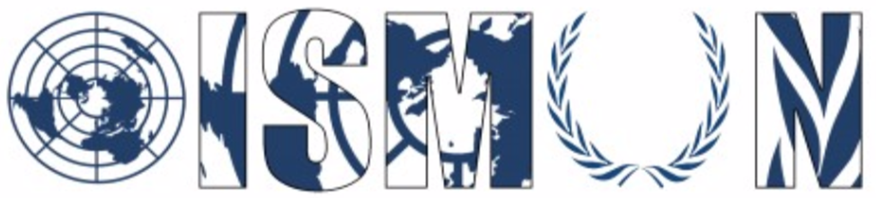

Oasis International School Model United Nations

Historical Security Council

President : Jana Maarek
Vice-President : Jana Khaled

Guiding Package
Topic 1 : The Korean War (1950-1953)

14th Annual OISMUN Conference

October 2021
Table of Contents:
I. Abstract……………………………………………………...….…….2
II. Introduction……………………………………………….…….…....3
III. Definition of Key Terms …………………………….………….…...5
IV. Background Information………………………………………….….6
V. Major Countries and Organizations Involved …………….…….…9
VI. UN Involvement ……………………………………………………..11
VII. Possible solutions…………………………………………………...12
VIII. Guiding Questions…………………………………………………..13
IX. Useful Links……………………………………………………….....14
X. Bibliography……………………………………………………….…15
XI. Appendix……………………………………………………...…...…17

- ABSTRACT
In June 1950, North Korean soldiers crossed the 38th parallel border between the two Koreas and carried out an invasion plan in South Korean territory. The anti-communist president (who was as much of a dictator as his North Korean counterpart), Syngman Rhee of the Republic of Korea (South Korea), supported by the United States of America and the United Nations, and the communist dictator, Kim Il Sung of the Democratic People’s Republic of Korea (North Korea) supported by the Soviet Union (USSR) and the People’s Republic of China, not only clashed ideologically and politically, but also territorialy; neither dictator wanted to limit themselves behind the 38th parallel, and Kim Il Sung of North Korea was the first to take a step towards his country’s expansion. This invasion is considered the first armed warfare of the Cold War which resulted in over 2.5 million casualties.
It will then amount to a full-blown war which will end in double the casualties, with more than half being civilians. The United Nations Security Council adopted 4 resolutions surrounding this conflict, until it was taken off the agenda of the council in January 1951. The resolutions fully supported the Republic of Korea and encouraged the United States’ command of the assistance and military intervention in favor of South Korea, seeing as the USSR who supported the North was boycotting all Security Council resolution talks (because they were protesting the Chinese communist government being not allowed to partake in the council) earlier that year.

- INTRODUCTION
Before the end of World War II, the Korean peninsula was part of the Japanese Empire colonies, however due to the latter’s defeat in the war, the colony was freed. Although China, Manchuria and other Japanese colonies had native governments and took back control of their land after the departure of Japanese troops, Korea did not have a native government to go back to, seeing as it had been part of the Japanese empire since the beginning of the 20th century. Therefore, in August 1945, the two superpower countries of the Second World War, USSR and the USA, decided to divide Korea between them, with the USSR taking control of the north part and the USA taking control of the south. The border separating the two territories is called the 38th parallel.

In the South, Syngman Rhee, a nationalist who got his education from the US, was appointed President of the Republic of Korea and kept close ties with the US. On the other side, Kim Il-Sung, a North Korean Marxist revolutionary that was a major in the Soviet army, put in place a communist government in North Korea, with the support of the Soviet Union. In 1949, he started pressuring Joseph Stalin, the leader of the Soviet Union, to start an invasion of South Korea to expand their communism to the rest of the peninsula. After many preparations to the army and equipment of North Korea, Stalin finally approved an invasion in March-April 1950. On June 25th, around 100,000 North Korean soldiers of the North Korean’s People’s Army (KPA) crossed the 38th parallel to South Korea. The USA, fearing a communist take-over that would spread to the rest of the world, helped South Korea hold a defensive position by sending armed forces, but neither country was at all prepared for this surprise attack, leading to the North Korean troops reaching Seoul, the capital of South Korea. This invasion is what started the Korean War, which will result in 5 million deaths, 40,000 of whom were American soldiers.

- DEFINITION OF KEY TERMS
1- Peninsula: An area of land that is surrounded by water on three sides, i.e., the Iberian Peninsula (Portugal + Spain)
2- Superpowers: The United States and the USSR during the Cold War, because they both had possession of atomic bombs and had the most powerful armies.
3- Native government: A country’s government before colonization; their own political system.
4- Nationalism: Movement and idea that promotes a nation’s independence and sovereignty over its own interests.
5- Marxism: The origin of communism. Theory and ideology developed by Karl Marx which supports the materialistic development of society in the course of history.
6- Boycott: To withdraw from relations or from cooperating with a policy as a form of protest.
7- Demilitarized zone (DMZ): An area where a treaty or agreement between military powers forbids any military activities, installations or personnel. It’s usually the area bordering two or more nations or military powers.

- BACKGROUND INFORMATION
- Origins:
After the USSR and the USA’s victory in the Second World War, they had to decide what to do with their enemies’ territories, notably Japan. Since the 19th century, Korea and Manchuria had been of great importance to the USSR, the People’s Republic of China and Japan. With Japan out of the picture, the Soviets made a move in an attempt to occupy Korea. However, with the rising political struggle for world domination between the USSR and the USA, the latter decided to occupy the southern half of Korea, so they wouldn’t let the USSR get too much control of the territory. Just like the eastern and western division of Germany, the North built a communist government while the South built a nationalist, anti-communist government.

- The North Korean Attack:
On June 25, 1950, the Korean War began. At four o'clock in the morning, the border between the Democratic People's Republic of Korea (North Korea) and the Republic of Korea (South Korea) was set ablaze. Thousands of artillery tubes unleashed fire on the positions that the North Korean troops were going to storm. 600,000 fighters of the communist regime of North Korea surprised the South Koreans with a massive invasion that crossed the 38th parallel and hit the border town of Ongjin first. The majority of South Korea was invaded and Seoul, the capital, was taken after only three days of fighting (In early autumn, the southern troops held only a small reduction in the south-east of the country in the Busan region). The invasion of South Korea took Washington by surprise but, nevertheless, the United States did not remain inactive.

- The US and UN intervention (UN Resolution 82):
After the attack, friendly relations between the two superpowers begin to break down. The South Koreans, after the invasion, had only Busan in the south of the peninsula, where they were. The United States, totally displeased by the attack, decided to take action and 'revenge' on North Korea and the USSR. It takes advantage of the boycott of the USSR in the sessions of the Security Council - because of the refusal of the UN to admit the new Chinese communist regime as one of the five permanent members of the committee - and that they do not have the right of veto, to go to vote an intervention in the Security Council. During this time, the UN only recognized the People’s Republic of Korea as a lawful government. The first UN resolution, made therefore in light of the attack, called on the retreat of the Northern troops from the Southern territory. However, due to North Korea ignoring this resolution, the scale of the war grew more international and the United States further increased its intervention. The committee then admits the North Korean aggression, and decides to form a multinational military force to repel and confront the North Koreans.
Their efforts paid off because on September 15, 1950, when the North Korean forces were ready to invade the rest of South Korea, the South Korean-American army, led by Douglas Macarthur, headed for Incheon, a port near Seoul in the Yellow Sea. They clashed with North Korean forces, finally reaching Seoul and reclaiming the 38th parallel.
The victory of the UN troops was announced when they succeeded in reaching the Chinese border, on the banks of the Yalu River.

- United Nations Security Council Resolution 84:
On July 7th, 1950, this resolution was adopted to encourage all members to furnish help and aid to the Republic of Korea and in hopes to make all forces and assistance going there be available to a unified command under the United States. This command would use the flag of the United Nations and would report back to the United Nations on the actions taken by the command. General Douglas MacArthur was put in charge of this command.

- United Nations Security Council Resolution 85:
It was adopted on July 31st, 1950, and allowed the United Nations Command (created thanks to resolution 84) to give aid to the Korean civil population by gaining the support of Non-Governmental Organizations (NGOs) and UN specialized committees.

- Chinese Counter-Offensive:
Following the counter-offensive, On November 26, 1950, the Chinese pushed the South Korean allies back to the South, crossing the 38th parallel. At the beginning of 1951, the American General Douglas MacArthur insisted on using the atomic bomb.

- MAJOR COUNTRIES AND ORGANIZATIONS INVOLVED
- Organizations involved
- The United Nations Command (UNC): This was the command created after resolution 84 was adopted by the Security Council, under the United Nations’ flag but led by the US and General Douglas MacArthur. The United Nations Command was one of the main sources for military and strategic direction for the anti-communist war effort in Korea. The United States provided for the UNC everything they would need to intervene: logistics, air and naval power, artillery and military infrastructure.
- The United Nations Commission on Korea (UNCOK): This commission was created before the Korean war to monitor the occupation of the two Koreas. In 1950, when the war took place, UNCO monitored all activities ongoing. Two Australian Observers, Major Peach and Squadron Rankin, were on Korean ground just after the attack. Their position was of extreme value since they were the only UNCOK observers in place when North Korea invaded South Korea on the 25th of June 1950. Their report proved that North Korea initiated all actions and provided evidence needed for the UN to intervene in South Korea and in the war.

- Countries involved
- The Democratic People’s Republic of Korea (North Korea): Despite not being a member state of the United Nations during the time of the conflict, the Democratic People’s Republic of Korea represented the main country involved in the war and in this topic seeing as it is the country that carried out the invasion plan.
- The Republic of Korea (South Korea): Another country that was not a member state of the UN but was the principal country involved in the conflict, because it provided the main field of battle throughout this war. It was the opposing power against the Democratic People’s Republic of Korea.
- The United States of America: The USA was one of the major contributors to this war seeing as it was one of the Republic of Korea’s biggest allies. It used this war to try to show that it was not “soft on communism” and to try and stop the USSR’s ideological expansion. It contributed the most soldiers (almost 2 million) and used the UN as a foreign policy tool in building an international peace-keeping force which mostly consisted of American soldiers.
- The Soviet Union: The country that supported North Korea the most, and which also had the biggest influence on this war, seeing as the invasion plan wouldn’t have been carried out if it wasn’t for Stalin’s approval. However, they did not have a direct involvement in the war, only aiding Northern troops with weapons and supplies.
- The People’s Republic of China: Another country that supported North Korea. They sent their troops and aid to North Korea and supported the invasion plan.
- The United Kingdom of Great Britain and Northern Ireland: They fought alongside South Korea by sending around 60000 military troops and supporting the US’ appeal to the United Nations.
- Dominion of Canada: They sent aircraft and other military equipment with the United Nations in support of South Korea.
- Republic of Turkey: They sent the 1st Turkish Brigade as support to South Korea after the UN called upon 21 countries to send aid to the country.
- UN INVOLVEMENT
Before the war, President Truman had called upon the UN to take responsibility for Korea and for its political future, hence the creation of the UNCOK. The United Nations Security Council adopted 4 resolutions regarding this topic, and the General Assembly adopted 4 as well. The United Nations were in complete support of South Korea and requested the aid of 21 countries in halting the North Korean attacks on the Southern Territory. The United States of America were the main reason the United Nations intervened in the conflict, as they brought attention to North Korea’s invasion and called for immediate assistance to South Korea. The biggest UN contributor was the United States of America, which had around 140,000 troops deployed in combat in Korea. Countries such as the Great Britain, France, South Africa, Canada, Turkey, Greece sent fighting units. Italy, amongst other countries, provided military hospitals and field ambulances for the war.

- POSSIBLE SOLUTIONS
- Apply sanctions to the Soviet Union and the People’s Republic of China for breaching the UN charter by supporting North Korea.
- Create an agreement with both parties’ interests, which includes a ceasefire.
- Suggest a unification plan for both countries with one political government.

- GUIDING QUESTIONS
- What position did your country have during this conflict?
- What could the UN have done differently?
- If the USSR hadn’t boycotted UN procedures, what would have gone differently?
- How was your country supporting each party?
- What would your country’s main response be to the Nuclear war threat emitting from this war?
- What main events of the war should’ve been discussed in the UN Security Council?
- How would you implement solutions that would maintain peace and security and end the tension and conflict between the two territories, as well as the rising Cold War?

- USEFUL LINKS
- Short dpcumentary about the civil war in Korea: https://www.youtube.com/watch?v=-X7nbwFxGRU
- Video explaining the key ideas and concepts regarding the confilct: https://www.youtube.com/watch?v=h1wFrXKanC0
- Site recapitulating all Korean War events: https://www.britannica.com/event/Korean-War
- Site providing information regarding The UN’s involvement in Korea: https://www.trumanlibrary.gov/education/presidential-inquiries/united-nations-korea
- Site detailing the participation of France in the war: https://www.researchgate.net/publication/307737414_The_French_Participation_in_the_Korean_War_and_the_Establishment_of_a_Path_of_Memory_in_South_Korea

- BIBLIOGRAPHY
- HISTORY.COM Editors, “Korean War”. May 11 2020. Available on: https://www.history.com/topics/korea/korean-war#section_1 . Consulted on September 14, 2021.

- UN SECURITY COUNCIL, “Resolution concerning the complaint of aggression upon the Republic of Korea adopted at the 478th meeting of the Security Council on 7 July 1950”. 7 July 1950. Available on: https://digitallibrary.un.org/record/474613?ln=en . Consulted on September 14, 2021

- R. MILLET Allan, “Korean War”. September 10 2020. Available on: https://digitallibrary.un.org/record/474613?ln=en . Consulted on September 17, 2021.

- ANONYMOUS, “The United Nations in Korea”. Available on: https://www.trumanlibrary.gov/education/presidential-inquiries/united-nations-korea . Consulted on September 18, 2021.

- HEIN Andrew, “A History of the Korean War”. 26 March 2012. Available on: https://www.youtube.com/watch?v=-X7nbwFxGRU . Consulted on September 18, 2021.

- UN COMMISSION ON KOREA, “Report of the United Nations Commission on Korea : covering the period from 15 December 1949 to 4 September 1950”. 1950. Available on: https://digitallibrary.un.org/record/704714?ln=en Consulted on September 18, 2021.

- UNSC, “Resolution 82 adopted by the United Nations Security Council (New York, 25 June 1950)”. 3 July 2015. Available on: https://www.cvce.eu/en/obj/resolution_82_adopted_by_the_united_nations_security_council_new_york_25_june_1950-en-64ad35a0-24eb-41c6-b812-f843ad11211d.html . Consulted on September 18, 2021.

- HARPER Paul & ROGERS Jon, “When was the Korean War, which countries were involved and will the North and South commit to denuclearisation?”. 26 February 2019. Available on: https://www.thesun.co.uk/news/4386596/korean-war-kim-jong-un-north-south-denuclearisation-moon-jae-in/ . Consulted on September 18, 2021.

- SPARKSNOTES EDITORS, “The Korean War (1950-1953): Study Guide”. Available on: https://www.sparknotes.com/history/american/koreanwar/ . Consulted on September 24, 2021.

- APPENDIX

Photo presenting the Korean War map, and the many attacks that occured on the region chronologically: https://www.blendspace.com/lessons/Fi4PiwcaC7Owmg/korean-war-red
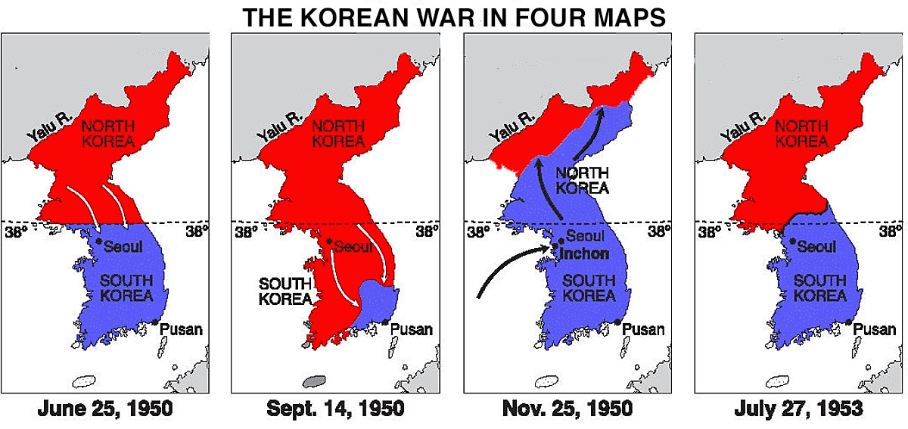

Latitude 38˚ north; the border separating North Korea from South Korea put in place after World War II.
A region in China neighboring Korea.

