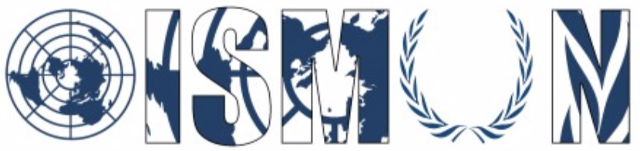
Oasis International School Model United Nations
Human rights council

President: Amr El Nomrosy
Vice-President: Yehia Bahei

Guiding package

Topic 1: The right to freely express one’s opinion on online platforms without
fear of censorship or reprisal from governments

14th Annual OISMUN conference
November 2021
Table of Contents
- Abstract: 2
- Introduction: 3
- Key terms: 7
- Background Information: 5
- Un involvement: 8
- Main countries involved: 9
- Main organizations involved: 13
- Useful links: 14
- Possible solutions: 16
- Guiding questions: 16
- Bibliography: 17

Abstract:

As stated in the Universal Declaration of Human Rights, Article 19: “Everyone has the right to freedom of opinion and expression; this right includes freedom to hold opinions without interference and to seek, receive and impart information and ideas through any media and regardless of frontiers”. Nowadays, online platforms/social media act as a medium of providing, publishing, and spreading crucial information/opinion.

Throughout the whole world, most of the governments regulate media using measures, restrictions, and regulations. These restrictions and regulations vary from one government to another. For example, some countries would just ban the account for a certain period and some of them can be banned for life. Other countries just delete the post and don't allow its publishing. Each country applies those regulations/restrictions to maintain its political stability. Moreover, countries may use political stability and national security as motives. Currently, most of the serious situations are related to non-democratic countries. Nowadays, media and online platforms are important politically because throughout these platforms, information is gathered and published in favor or against a certain politician/government.
For some governments in order to stay in power, they use the media as a weapon to defend themselves. They use the media to manipulate and publish information in favor of the governor/politician. It’s used to brainwash the whole population. Furthermore, they do not give a chance to anyone to use the media to attack them which can affect their hold on power. Therefore, some countries would take complete control of the media to filter what will be published. If anyone publishes any information without approval, he could face censorship. This can have as a result a total ruining of democracy.

Introduction:
Two Decades ago, social media was launched and with the passage of time, people became more attached to it and started using it more and more. With the spread of social media over the world with the number of users increasing day by day, social media became a threat for most of the governors. Before social media, the only threat to them was “Journalism”. Most of the governors took control of the press either newspaper, magazines and others.

After social media became a threat, some governors took complete control over it to disallow the publishing of any information against the governments. Some countries banned all global social media from their countries even for foreigners, some created their own internet for their population to disallow their communication with the other countries. This internet connection is only accessible in the country and no one out of the country can connect or use this network. In addition, they also disallowed all the international channels. Some other countries created a copy of social media but under the control of the cyber-police.
On one hand, most of the governors right now use (National security & political stability) as arguments to defend their acts (Deleting posts, censorship etc…). On the other hand, some governors give their population complete freedom to discuss any topic except for the topics which can cause problems for the government. For example, most of the countries that are free such as Norway, Finland etc… do not allow for their population to incite others to commit a terrorist act or acts. This means that all countries even if they give to its populations the freedom to express their opinions, but there are topics that are restricted by the UN such as terrorism.

Definitions of key terms:
Censorship: Censorship is the suppression of speech or public communication. This action may be conducted by private institutions, governments and other controlling heads based on their perspectives and thoughts on the published content in order to protect the predominant ideology from which those benefit most who have attained power, wealth, status, and control within society. The publications may be considered harmful, sensitive, objectionable or inconvenient.
Political stability: Political stability is a variable that controls countries’ economic growth and development speed. It helps to build a coherent path for sustainable development.
Internet shutdown: An Internet shutdown is an intentional disruption of Internet-based communications for a certain period of time. It becomes ineffective and unavailable for an organization, a certain number of people, city, country and more. Internet shutdown can take place to disturb communication between protestors for example.
Rehabilitation: Rehabilitation is the process of re-educating people who commit crimes. It involves a psychological approach in order to keep track of criminals’ attitude to make sure that they are on the right track.

Background Information:
The question of censorship and the disallowing of publishing any information against the governors is not at all new to humanity. In fact, this problem existed decades ago even though social media platforms were not even launched. Some countries took the measures they are currently applying but with journalists, magazine articles etc… Before, some countries employed people just to check what is written and what is going to be published and decide if this will affect the government or not. Nowadays, countries use many ways to enforce censorship on posts, tweets etc… One of the most known strategies is keywords filtering. This strategy is mainly based on having a list of all the posts, tweets etc… containing this word, and then reading all the posts and choosing those who will be published.

IP blocking also is a very well-known strategy in which countries use security websites to disallow people with specific IP addresses from using, browsing, or performing any activity on websites. Mostly, these strategies are applied by non-democratic countries. In general, countries that are not democratic do not give any form of freedom to its population and this is totally against the Human Rights Chart which allows anyone to express their point of view through any medium without fear of censorship or reprisal from countries. The only case in which countries are allowed to intervene are cases regarding national security.
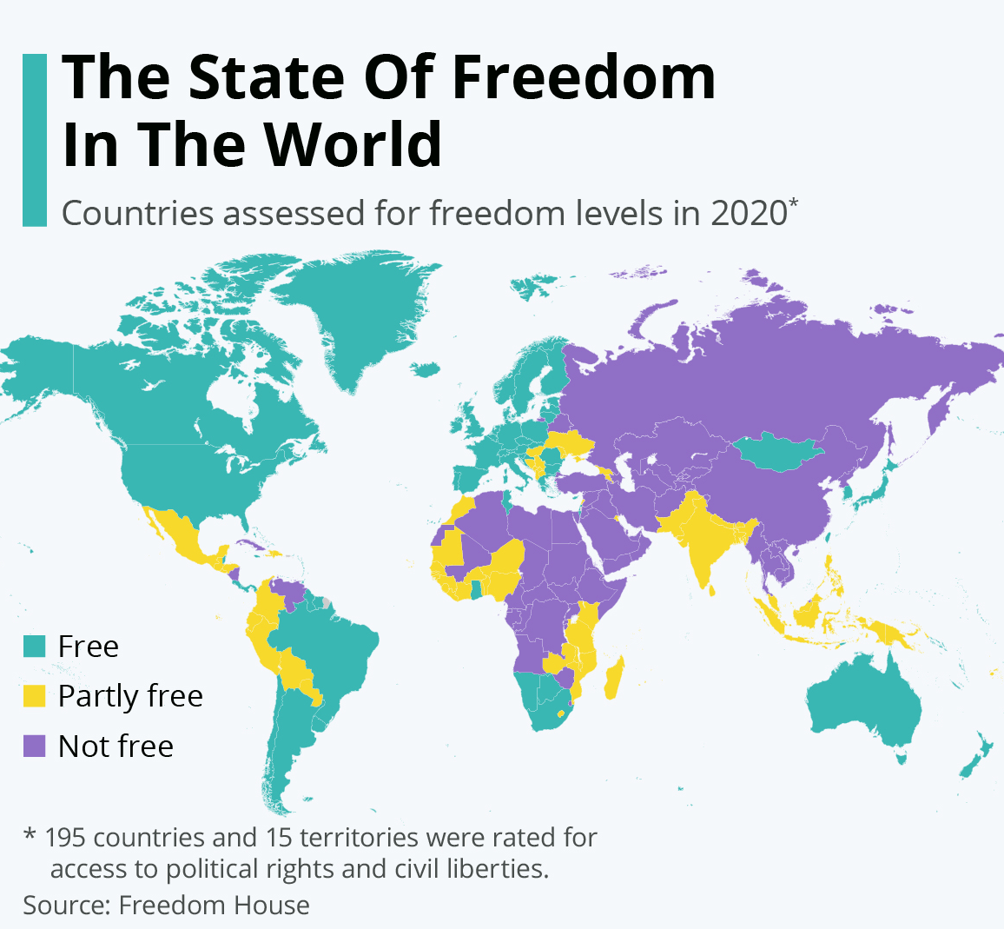
Previously, we presented the most well-known strategies for applying censorship, but there are also many other strategies applied by other countries. For example, the strategies applied by North Korea. The government of Kim Jong Un wanted to take complete control of social media, so they decided to create an internet connection for its population to be able to track any activity on social media without being obligated to hack phones etc… In addition, Kim saw that it’s not enough to just disallow the global network, but he decided to create his own social media platforms to make the tracking much easier. He banned all social media platforms such as Instagram, Facebook, YouTube etc… and substituted them with some social media platforms already created by The People’s Republic of China and some other applications. Global internet is only allowed for some hotels for foreigners and disallowed for citizens. And it is also allowed in some governmental entities.
Another example is China, who did something similar to North Korea. They also wanted to take complete control of social media, so they replaced all global social media platforms with national platforms like Sina Weibo, WeChat etc… They are replacements of Twitter, Facebook, messenger etc… They did so to allow communication between Chinese people without being able to contact foreigners. The Chinese government even after taking all these measures does not allow its population to publish any political opinion because it’s mainly directed to Chinese people and this can cause revolutions and protests.

UN involvement:
The United Nations has been working on freedom of expression’s topic for years, but lately topics regarding freedom of speech, especially in the Human Rights Council, have been raised a lot. The UN with most of his committees have been working on resolving this problem especially that nowadays social media has become one of the most used methods to express yourself. Journalists, citizens and workers started to fear their government because of the restrictions made to reduce the media’s influence on people’s opinions and control their thoughts to follow a certain system. Citizens started to receive death threats, jail alerts and torture which is completely against article 19 in the HRC.

Freedom of expression has been discussed and hundreds of resolutions have been submitted to protect people and improve their living conditions and freely express themselves. Freedom of expression has always been one of the Human rights council’s priorities. One of the most recent resolutions is the resolution discussed in the 44th session of Human Rights. It was discussed for 18 days straight. This resolution reaffirms the right to freely express yourself. It was also strengthening and encouraging the countries to stop censorship, internet shutdowns. This resolution was concentrating on two points. These 2 points are surveillance and the safety of the journalists or the publishers in general. Another resolution was adopted by the Security Council regarding the same problem on the 12th of March 2021. They were discussing the freedom of expression in the world and how this can affect the political stability of a region and/or maybe the political stability of the whole world.

Useful Clauses:
-As reported in the United Nations Security Council Resolution 1624, Article 1: “Calls upon all states to adopt such measures as may be necessary and appropriate and in accordance with their obligations under international law:
- Prohibit by law incitement to commit a terrorist act or acts;
- Prevent such conduct;
- Deny safe haven to any persons with respect to whom there is credible and relevant information giving serious reasons for considering that they have been guilty of such conduct.
-As stated in the International Covenant on Civil and Political Rights, Article 19 : “It may therefore be subject to certain restrictions, but these shall only be such as are provided by law and are necessary:
- For respect of the rights or reputations of others;
- For the protection of national security or of public order (order public), or of public health or morals.”
-In relation to the right to freedom of expression ; various International Human Rights Instruments provide as follows :
→ “Everyone has the right to freedom of opinion and expression; this right includes freedom to hold opinions without interference and to seek, receive and impart information and ideas through any media and regardless of frontiers.” [Article 19, Universal Declaration of Human Rights, 1948 (UDHR)]
→ “Everyone shall have the right to hold opinions without interference. Everyone shall have the right to freedom of expression; this right shall include freedom to seek, receive and impart information and ideas of all kinds, regardless of frontiers, either orally, in writing or in print, in the form of art, or through any other media of his choice.” [Article 19 (2), International Covenant on Civil and Political Rights, 1966 (ICCPR)]

Major countries involved:
People’s Republic of China (PRC)&: China is known for its severeness and aggressiveness especially when it comes to topics related to politics and system.. This means that China doesn’t give its population complete freedom to express their point of view on any political topic. To be able to manage and control social media, the People’s Republic banned all global social media platforms such as Instagram, Facebook, Google etc… and replaced these platforms with other national social media platforms under the control of the government and the cyber-police. For example, Sina Weibo is China’s twitter, WeChat is China’s Facebook and Messenger. All of these applications and other applications are also not totally free because the main purpose of creating such platforms is to allow only Chinese people to communicate with each other while there is no contact with foreigners and also under complete surveillance of the country. They don’t allow the publishing of any political information against the system, especially that this information is directed only to the Chinese population which can push the rest of the population to revolt against the governor.
Democratic People’s Republic of Korea (North Korea): A decade ago, Kim Jong Un inherited power from his father Kim Jong Il. He became the most powerful president in the history of Korea. He started concentrating on taking control of everything in the country as his father did. But Kim had as a top objective getting social media under the supervision of the government. Later, he blocked Google, Twitter, Facebook from his country in April 2016 even though the most accessed platform in North Korea at this time was Facebook. He substituted all these platforms with a limited number of Chinese platforms such as Youku Tudou (YouTube). In addition, since 2013 global internet connections are banned in the whole country except for the hotel for foreigners and some governmental entities. Nevertheless, he also banned anyone from publishing any political point of view on these platforms. In addition, he created a network connection for his population (Not all of them have accessibility for Chinese social media platforms) to be able to surveil the population.
The United Kingdom of Great Britain and Northern Ireland (UK): Since the launching of social media platforms, the population of the UK has become one of the most users of these platforms until our days. According to multiple research and statistics, more than 48 million are social media users. In other words, the percentage of users in the UK is approximately more than 75% of the whole population. Based on article 10 from the law, this article summarizes how the population should use their rights correctly. To clarify, public authorities may restrict any information from being posted in order to: Prevent disorder and crime in the country, Protect the rights and reputations of other people etc… There are also topics that you’re not allowed to talk about such as encouraging ethnic, religious hatred. Here is what the law says exactly: “Everyone has the right to freedom of expression. This right shall include freedom to hold opinions and to receive and impart information and ideas without interference by public authority and regardless of frontiers. The exercise of these freedoms, since it carries with it duties and responsibilities, may be subject to such formalities, conditions, restriction, penalties as are prescribed by law and are necessary in democratic society, in the interests of national security, territorial disorder or crime, for the protection of health or morals, for the protection of the reputation or rights of others, for preventing the disclosure of information received in confidence, or for maintaining the authority and impartiality of the judiciary.”
The United States of America (USA): The United States of America is known as one of the most effective and powerful countries in the whole world. They are also known as one of the most democratic countries in the world. A long time ago, the USA adopted a law that protects the freedom of press and freedom of speech. With the spreading of social media, the United States respected the law and gave complete freedom for the users. The government may also prohibit some speech because they see advocacy of illegal action and fighting words. To be able to do so, the Supreme Court in the United States requests from the government to provide justification for this prohibition and evidence also. To clarify, this means that it’s not sufficient to say that they are regulating speeches for political stability or national security as the other countries said, they need a justification and one evidence at least.
The Islamic Republic of Iran: The ministry of interior as well as the security and intelligence bodies didn’t allow the existence of any independent political party in Iran. In addition, foreign satellite channels are jammed in Iran. Even the social media is also blocked, Facebook, twitter and many other social media platforms are not allowed in Iran. Some of them are allowed but with limited access. Police forces can use anything in exchange for preventing anyone from spreading their point of view. For example, they fired pointed pellets and rubber bullets towards some protestors who were trying to express their point of view. Hundreds of Iranian journalists have been jailed since 2011 after being tortured to extract forced confessions. Iranis journalists have been heavily accused of supporting other restricted ideologies.

State of Eritrea: Eritrea is a main component in this dispute since it is a non-democratic country and restrictions mainly arise in non-democratic countries. They don’t allow political pluralism which means that there are no political parties allowed in the country other than the one governing. Any other political party must operate from a foreign country. Most of the political parties chose Ethiopia, their neighboring country, to be close to their country. Since 2001, the country has shut down all the media outlets who are not controlled by the government. More than 15 journalists are in jail and most of them are held incommunicado in secret detention centers. Eritrea is also ranked as one of worst countries in terms of freedom of speech.
Equatorial Guinea : Guinea is a non-democratic country. Guinea has no independent journalists, and all radio receivers in the country are locked to government-specified frequencies. State-run Radio Malabo broadcasts songs warning citizens that they will be crushed if they speak against the regime. Guinean citizens receive death threats if they try to express themselves which genuinely makes Guinea involved in this topic.

Major organizations involved:
Center For Low and Democracy (CLD): The Center for Law and Democracy is a Non-Governmental Organization that is aiming to promote and protect Human Rights. It is protecting all human rights including the freedom of expression and freedom of opinion. It is mainly funded by governments and international institutions. Most of the work that is done by this center is done in collaboration with many other organizations. For example, one of their recent activities was with the International Federation of Journalists. It is also supporting all the countries. For example, one of the projects they are currently working on is in Myanmar. They are helping Myanmar with their democratic transition. They are always in contact with the UN, and they make regular submissions to inform them about some issues.

Committee to protect journalists (CPJ): It is a nonprofit and a Non-Governmental Organization founded in the early 80’s. It is aiming to support press freedom worldwide. They are defending the rights of journalists to publish their point of view without any fear of reprisal from the government. Mostly, every year, they publish the number and names of the journalists killed or imprisoned in the whole world. According to the American Journalism Review, they called them “Journalism’s Red Cross”. They chose this name because generally the Red cross is offering aid and protecting human life, so the name Journalism Red Cross is because they are offering aid and protecting the rights of journalists.

Guiding Questions:
- To what extent political instability may be a severe cause for censorship and limit people’s chance to express their opinions on online platforms?
- How can countries put aside their personal ideologies and perspectives in order to fight censorship and give people the right to express themselves freely?
- To what extent internet shutdowns may be considered an act of censorship in order to deny people’s access to the internet to limit their right to express themselves?
- How does censorship affect a country's political stability?

Possible solutions:
- Calls upon all states to protect the right to freedom of opinion and expression Online or Offline. Take all the necessary measures to prevent any violation of this right and ensure that the national laws comply with the International Human Rights obligations.
- Ensure that everyone including Journalists, Human Rights defender, Media workers is exercising his right to publish his opinion or point of view. Assuring the protection of journalists in law and in practice. Promoting multiple points of views and opinions.
- Encourage all states to adopt laws and policies that guarantee the right to receive, seek and publish any information. Taking the necessary measures and procedures to facilitate the access and the use of information.
- Requests all states to prohibit the calling of racial or religious hatred online that incites to violence or discrimination. Affirm the importance of fighting all acts of incitement to discrimination, violence in accordance with the International Covenant on Civil and Political Rights.

Useful links:

- https://www.ohchr.org/en/professionalinterest/pages/ccpr.aspx
- https://www.statista.com/chart/12541/the-state-of-freedom-worldwide/
- https://notesfrompoland.com/2020/04/21/poland-falls-to-lowest-ever-position-in-world-press-freedom-index/
- https://www.dragonsocial.net/blog/social-media-in-china/
- https://www.pewresearch.org/global/2019/04/29/publics-satisfied-with-free-speech-ability-to-improve-living-standards-many-are-critical-of-institutions-politicians/

Bibliography:
- MEGATRENDS, Global. « The State of Freedom in The World ». 4th of March 2021. Consulted the 1st of September 2021. https://www.statista.com/chart/12541/the-state-of-freedom-worldwide/
- ANONYMOUS. « Poland Falls to Lowest Ever Position in World Press Freedom Index ».
21st of April 2020. Consulted the 1st of September 2021. https://notesfrompoland.com/2020/04/21/poland-falls-to-lowest-ever-position-in-world-press-freedom-index/
- RUAN, Lotus. « Regulation of The Internet in China: An Explainer ». 7th of October 2019. Consulted the 4th of September 2021. https://theasiadialogue.com/2019/10/07/regulation-of-the-internet-in-china-an-explainer/
- REDDY, Shreyas. « Analysis: How does North Korea use social media? ». 5th of July 2019. Consulted the 4th of September 2021
- ANONYMOUS. « Article 10: Freedom of expression ». 3rd of June 2021. Consulted the 1st of September 2021 https://monitoring.bbc.co.uk/product/c200xiwn
- ZIVKOVIC, Jovan. « 50+ Interesting Social Media Statistics UK ». 17th of July 2021. Consulted the 4th of September 2021. https://cybercrew.uk/blog/social-media-statistics-uk/
- ANONYMOUS. « Everything you need to know about Human Rights in Iran ». 2020. Consulted the 4th of September 2021. https://www.amnesty.org/en/location/middle-east-and-north-africa/iran/report-iran/
- ANONYMOUS. « Eritrea: Freedom in The World 2021 ». 2021. Consulted the 14th of September 2021. https://freedomhouse.org/country/eritrea/freedom-world/2021
- ANONYMOUS. « Equatorial Guinea: Freedom in The World 2020 ». 2020. Consulted the 14th of September 2021. https://freedomhouse.org/country/equatorial-guinea/freedom-world/2020
- DEGENNARO, Tony. « 10 Most Popular Social Media Sites in China ». 30th of June 2021. Consulted the 6th of September 2021. https://www.dragonsocial.net/blog/social-media-in-china/
- ANONYMOUS. « Hate Speech vs Free Speech: UK Laws ». 12th of February 2020. Consulted the 8th of September 2021. https://www.theweek.co.uk/97552/hate-speech-vs-free-speech-the-uk-laws
- RIGHTS, Human. « International Covenant on Civil and Political Rights ». 16th of December 1966. Consulted the 1st of September 2021. https://www.ohchr.org/en/professionalinterest/pages/ccpr.aspx
- WIKE, Richard. « Publics satisfied with free speech, ability to improve living standards; many are critical of institutions, politicians ». 29th of April 2019. Consulted the 1st of September 2021. https://www.pewresearch.org/global/2019/04/29/publics-satisfied-with-free-speech-ability-to-improve-living-standards-many-are-critical-of-institutions-politicians/

MEGATRENDS, Global. « The State of Freedom in The World ». 4th of March 2021. Consulted the 1st of September 2021. https://www.statista.com/chart/12541/the-state-of-freedom-worldwide/
ANONYMOUS. « Poland Falls to Lowest Ever Position in World Press Freedom Index ». 21st of April 2020. Consulted the 1st of September 2021. https://notesfrompoland.com/2020/04/21/poland-falls-to-lowest-ever-position-in-world-press-freedom-index/
https://monitoring.bbc.co.uk/product/c200xiwn
https://documents-dds-ny.un.org/doc/UNDOC/GEN/N05/510/52/PDF/N0551052.pdf?OpenElement
RIGHTS, Human. « International Covenant on Civil and Political Rights ». 16th of December 1966. Consulted the 1st of September 2021. https://www.ohchr.org/en/professionalinterest/pages/ccpr.aspx
RUAN, Lotus. « Regulation of The Internet in China: An Explainer ». 7th of October 2019. Consulted the 4th of September 2021. https://theasiadialoguina/ e.com/2019/10/07/regulation-of-the-internet-in-china-an-explainer/
DEGENNARO, Tony. « 10 Most Popular Social Media Sites in China ». 30th of June 2021. Consulted the 6th of September 2021. https://www.dragonsocial.net/blog/social-media-in-china/

