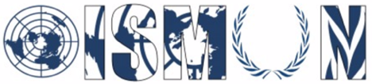

Oasis International School Model United Nations

General Assembly

President: Salma Ahmed
Vice-president: Aly Samir

Guiding Package

Topic: The Question of Global Nuclear Weapon Proliferation

14thannual conference OISMUN
October 2021

Table of Contents

Abstract………………………………………………………………………...3
Introduction…………………………………………………………………….4
Key Terms Definition…….…………………….………………….……..…...5
Background Information….………………………………………………….5
Major Countries involved and Major Organizations Involve……..…...10
UN Involvement………………………………….…………………………….15
Possible Solutions.………………………………………..………………….15
Guiding Questions…………………………………….…………………..….15
Useful Links….…………………………….…………………………………16
Bibliography………………………….……………………………………… …16

Abstract:
Nuclear weapons create an insurmountable threat to humanity. These weapons of mass destruction can devastate entire cities in mere seconds. They are highly costly, so a small minority of countries have the resources necessary to fabricate such catastrophic armaments. Not only is this worrisome for any country directly attacked, but the massive radius and size of these weapons would damage other countries in the surrounding area. Nuclear proliferation, whether it is among nations or terrorists, significantly increasing the possibility of nuclear violence to another insufferable level of violence.

Nations are highly wary of using such weapons due to the known outcome, but they use them as a defensive tool. Many nations who do not have such devastating power are protected by others that do, in order to dissuade any attempts at nuclear war. These weapons create a fear factor around the entire globe due to its destructive power.

The nuclear world is divided into two competing sections, on one hand a large majority of countries support “a nuclear weapon free world” which has resulted in nuclear weapons being forbidden in many areas on earth and beyond. Yet on the other hand, due to prestige, power and security a small sum of countries still maintain nuclear arsenals, and the percentage of these nuclear weapons has increased in the past 70 years.

Technological advancements undergo a long phase for them to be relied upon in the defense of nations. Fundamental revaluation of the role of nuclear weapons in national protection and defense should take place instantaneously to evade nuclear catastrophe. The continuous neglect of this issue would certainly lead to a major disaster in the future.

Introduction:

The threat of nuclear weapons is what keeps the world safe and peaceful. Even if many countries wish for there to be NWFZ around the world they could still be protected by another country that has nuclear weapons. This is the current paradox the entire world is facing. We want a peaceful world protected by weapons that could erase entire countries in seconds. Which is why many countries advocate for the elimination and limiting of these weapon’s use and testing. Since it had been seen what effect these weapons of mass destruction could have this would mean total decimation of a country or multiple countries. Many countries are protected by these weapons which limit many types of conflict and have countries resort to more peaceful conduct to settle many issues in the world. This also increases fear and threat if there is tension between countries that do have these nuclear armaments. Furthermore, if a country suddenly decides to manufacture and develop their nuclear weapons, this could create worry around the world which could be disastrous.

Key Terms Definitions:

- Proliferation: Rapid increase in the number or amount of something.
- Nuclear Weapon: A bomb or missile that uses nuclear energy to cause an explosion.
- Weapon of Mass Destruction (WMD): A nuclear, radiological, chemical, biological, or other device that is intended to harm a large number of people.
- Neglect: Fail to care for properly.
- Nuclear Weapon Free Zones (NWFZ): Areas around the world where there are no nuclear armaments.

Background Information:

- The Scientific discovery:
Since the scientific discovery of nuclear weapons at the end of the 1930s, the nuclear age has officially been declared started. The United states and its allies, during World War 2, were worried that their enemies would create nuclear weapons before them. Therefore in 1942, the US started a secret research effort named the Manhattan project. A project that was led by the US government to develop nuclear armament. Tensions between the US and the Soviet Union arose due to the use and creation of nuclear weapons. During the Cold War the threat of a nuclear war was an actual possibility.

- The creation of the IAEA:
In 1953, the USA's president Dwight D. Eisenhower announced the creation of the international atomic energy agency (IAEA). The goal of this agency was to oversee and encourage the peaceful use of nuclear arms. The USA's president at the time stated that an international organization was needed to avoid the spread and proliferation of nuclear technology. Furthermore, he mentioned that if the proliferation remains unchecked it may result in “the annihilation of irreplaceable heritage of mankind.”

- The Cuban Missile Crisis:
During 15 October 1962, a military plane owned by the US discovered Soviet nuclear missiles that were under construction in Cuba, that was close to the Florida coast. President John F Kennedy ordered the US Navy to enclose around Cuba and commanded the Soviet leader, Nikita Khrushchev to disassemble the missiles. After many tense days, the leader Khrushchev, agreed to dismantle the missiles but in Return the US would offer a public guarantee that it would not attack Cuba.

- Nuclear-Weapon Free Zone:

On February 14 the treaty of Tlatelolco was ready to be signed, where it established Latin America as the first Nuclear weapon free zone. Following the establishment of this treaty, many countries established Nuclear weapons free zones, such as the countries in the south pacific in 1985, following that Southeast Asia in 1995, then in Africa in 1996 and finally central Asia in 2006.

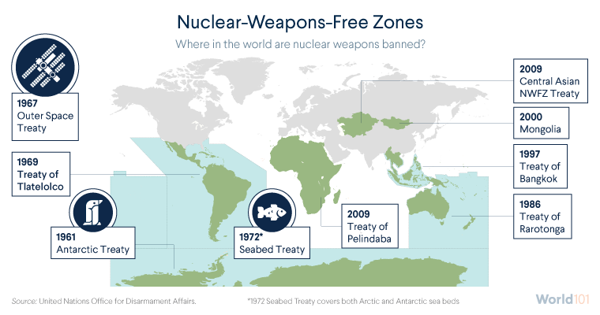

- The SALT I and II treaty
The first agreement to take place between the United States and the Soviet Union during the cold war, where they signed the Strategic Arms Limitations Talks agreement (SALT I), an agreement to limit their nuclear power resources during the cold war. This treaty has shocked history with its victory, as the nonproliferation of nuclear weapons between both parties for 10 years after the Cuban missile crisis. And after 7 years, SALT II was signed for further limited nuclear abilities.

- A new member other than the 5 NPT
In may 1974, India managed its first nuclear test, named Smiling Buddha. Even though the Indian government denied that any nuclear weapons program was taking place and claimed the explosions were for peaceful purposes. For the first time a country outside the original 5 NPT had tested a nuclear bomb. And in 1998, Pakistan also tested its first nuclear weapon.

- The Democratic people's republic of Korea withdraws from nonproliferation treaty:
North Korea proclaimed that it is withdrawing from the NPT Treaty stating that “We no longer remain bound to the NPT, allowing the country’s security and dignity of our nation to be infringed upon”. Although months earlier, the US had declared that North Korean Officials had started supplementing uranium for nuclear weapons. But North Korea denied the claim, however they reopened nuclear facilities that were shut down and ordered IAEA inspectors to leave the country. And after 4 years, The Democratic People's Republic of Korea’s government announced that they had completed a nuclear test. Becoming the 8th country in history to do so.

- Nuclear agreement with Iran:
During 2002, the US argued that Iran had started a nuclear weapon program. Researchers from the US published satellite photographs of what they identified as vital equipment in the proliferation of nuclear arms. In 2015, countries such as the United States, China, France, the United Kingdom, the European Union and others, reached a nuclear agreement with Iran after multiple years of discussions and negotiation, the Joint Comprehensive Plan of Action (JCPOA). Afterwards, Iran arranged to limit its nuclear program and subject its nuclear facilities to have much stricter monitoring than the usual IAEA safeguard. Nonetheless in 2018, the US president announced their extractions from the agreement and imposed sanctions on Iran.
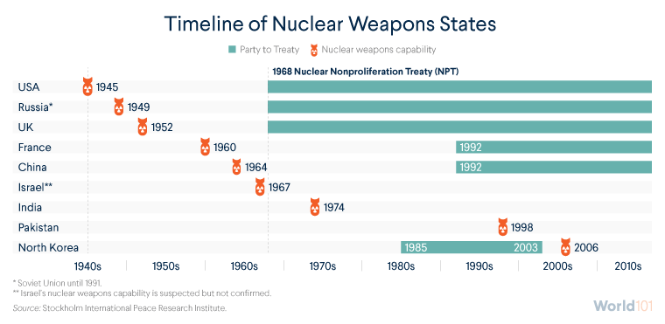
Major Countries and Organizations Involved:

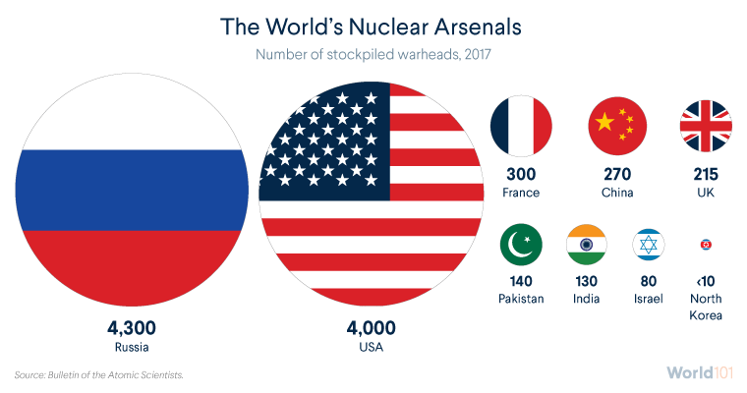

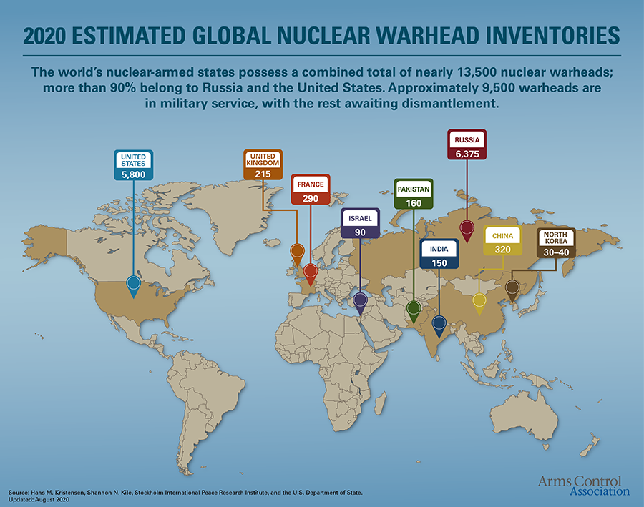
The United States of America: The country with the second greatest number of nuclear weapons. As well as being a country protecting other countries with its nuclear influence. Furthermore, they were the first country to develop and deploy nuclear arms on another country in 1945. The United States has begun to diminish its amount and the fabrication of nuclear weapons since the end of the cold war. The United States has not ratified the Comprehensive Nuclear-Test Ban Treaty (CTBT). Has ratified the Nuclear Non-Proliferation Treaty (NPT)
The Russian Federation: The country with the largest nuclear arsenal in the entire world. As well have tested many nuclear weapons with the first being in 1949. Has ratified the Comprehensive Nuclear-Test Ban Treaty (CTBT) and has ratified the NPT.
The People’s Republic of China: A country with heavy nuclear influence. One of the first countries to obtain nuclear power in 1964. China is also the country with the largest nuclear influence in Southern Asia. Furthermore, they have not ratified the CTBT, and have acceded to the NPT.
The United Kingdom of Great Britain and Ireland: The United Kingdom is one of the first 5 countries to obtain nuclear power. Conducting their first nuclear test in 1952. They are a country that wants to diminish the number of nuclear armaments in the world due to their destructive power. They have ratified the NPT and the CTBT.
The French Republic: The French Republic is one of the original five countries to obtain their nuclear power, conducting their first test in 1960. They have ratified the CTBT and are in accession to the NPT.
The Democratic People’s Republic of Korea: The Democratic People’s Republic of Korea is the latest addition to the list of countries with nuclear power. They are also the only country to have withdrawn from the NPT after having ratified it. They began testing nuclear weapons in the early 2000’s and since then have amassed a nuclear arsenal of about 40 nuclear warheads. They have also not ratified the CTBT.

The Republic of India: The Republic of India has been rapidly increasing its nuclear arsenal in the past few years, boasting approximately 150 nuclear warheads to its name. Currently they are one of the largest nuclear powers in the South Eastern Asia region. The Republic of India has not ratified the NPT nor the CTB.
The State of Israel: Despite the fact that Israel's nuclear program has been a closely guarded secret since a disgruntled technician, Mordechai Vanunu, revealed it in 1986, the official Israeli position has never been to confirm or deny its existence. Israel, unlike Iran, did not sign the 1968 NPT and thus could not violate it. However, it almost certainly violated a treaty prohibiting nuclear tests, as well as numerous national and international laws prohibiting the trafficking of nuclear materials and technology. The list of nations that secretly sold Israel the material and expertise needed to build nuclear warheads, or who turned a blind eye to its theft, includes today's most ardent opponents of proliferation: the United States, France, Germany, the United Kingdom, and even Norway.

Islamic republic of Pakistan: The Islamic Republic of Pakistan has been one of the early adopters of nuclear weapons since the late 1970s. Pakistan currently has the second largest nuclear arsenal in South Eastern Asia with approximately 160 nuclear warheads. This makes Pakistan one of the few countries in the world with such destructive capabilities to use in order to maintain peace. The country has yet to ratify the NPT or the CTBT.

UN Involvement:

- The United Nations adopts first Ban treaty:
At the United Nations, 122 countries have approved the Treaty for the Prohibition of Nuclear Weapons, the first legally binding nuclear disarmament treaty in 20 years. The countries that signed the treaty are based on the provisions of the Nuclear Non-Proliferation Treaty and the Comprehensive Nuclear Test Ban Treaty, and consider them an important step towards the elimination of nuclear weapons. However, the countries that already possess nuclear weapons have not signed it, so the effectiveness of the treaty remains to be seen.

- First international treaty to prevent the spread of Nuclear weapons:
In June 1968, the United Nations General Assembly passed a resolution and approved the preliminary text of the Treaty on the Non-Proliferation of Nuclear Weapons, and countries began to sign the treaty. Under this historic international agreement, non-nuclear weapon states agree that they will never acquire nuclear weapons; however, they can use atomic energy peacefully. The five countries that had nuclear weapons at the time - China, France, the Soviet Union, the United Kingdom and the United States - have joined the treaty, promising final disarmament, but have not yet done so.

- NPT goes global:
The late 1960s and early 1970s were characterized by progress and setbacks in nuclear non-proliferation worldwide. On the one hand, the United Nations established the first framework related to nuclear weapons through the Nuclear Non-Proliferation Treaty (NPT). The two largest nuclear powers in the world, the United States and the Soviet Union, took the lead in adopting measures to restrict nuclear arsenals. Yet on the other hand, India has acquired nuclear weapons.

Possible Solutions:

- Require countries to diminish their nuclear armaments and dismantle the weapons
- Setting a limit to the amount of nuclear warheads a country can possess.
- Banning Nuclear Testing throughout the world
- Allowing full development and production of nuclear warheads
- Limiting other countries to obtain nuclear weapons
Guiding Questions:

- Is your country a signatory to any of the treaties?
- Does your country possess any nuclear weapons ?
- What is your country’s opinion about nuclear weapons proliferation?
- What measures has your country adopted to prevent nuclear arms?
- Does your country have any agreement with the IAEA?
- Based on the IAEA, what are your country’s statistics on nuclear power reactors?

Useful links:
- https://world101.cfr.org/global-era-issues/nuclear-proliferation/history-nuclear-proliferation
- https://www.nti.org/learn/treaties-and-regimes/treaty-on-the-non-proliferation-of-nuclear-weapons/
- https://world-nuclear.org/information-library/safety-and-security/non-proliferation/safeguards-to-prevent-nuclear-proliferation.aspx

Bibliography:

World 101, “The History of Nuclear Proliferation”, [online]. ( June 2017). Available on: https://world101.cfr.org/global-era-issues/nuclear-proliferation/history-nuclear-proliferation
United Nations, “Treaty on the Non-Proliferation of Nuclear Weapons (NPT)”, [online]. (2020). Available on: https://www.un.org/disarmament/wmd/nuclear/npt/
TAYLOR B, Theodore, “Proliferation of Nuclear Weapons”, [online]. (2020). Available on: https://ee.stanford.edu/~hellman/Breakthrough/book/pdfs/taylor.pdf
NTI, “TREATY ON THE NON-PROLIFERATION OF NUCLEAR WEAPONS (NPT)”, [online]. (April 30 2020). Available on: https://www.nti.org/learn/treaties-and-regimes/treaty-on-the-non-proliferation-of-nuclear-weapons/
YOUNGER M. Stephen, “Nuclear Weapons in the Twenty-First Century”, [online]. (June 27 2000). Available on: https://fas.org/nuke/guide/usa/doctrine/doe/younger.htm
Arms Control, “Nuclear Weapons: Who Has What at a Glance”, [online]. (August 2020). Available on: https://www.armscontrol.org/factsheets/Nuclearweaponswhohaswhat

