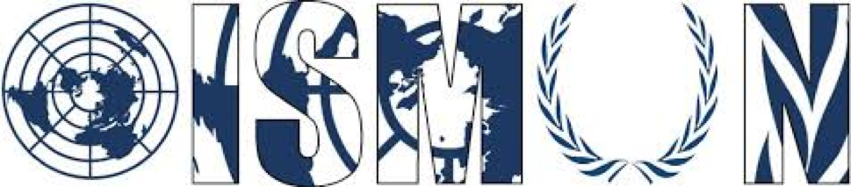

OASIS INTERNATIONAL SCHOOL MODEL UNITED NATIONS

General Assembly Fourth Committee:
Special Political and Decolonization

President Ali Salawi
Vice-President Raghda Gad

Guiding package

Topic (1): The territorial dispute over Western Sahara

12th Annual OISMUN conference

Table of Contents
- Abstract
- Introduction
- Definition of Key Terms
- Background Information
- Major Countries Involved
- Major Organizations Involved
- UN Involvement
- Possible Solutions
- Guiding Questions
- Bibliography

- Abstract :
The Western Sahara is a populated area that is situated in the northwest of Africa. The claim of which country has the authority over this territory is the reason behind the ongoing territorial dispute that has debuted in the 20th century. This conflict is mainly concentrated between Morocco, which currently controls the region, and the Polisario front, whom believe that Western Sahara should be made an independent state.
The surface of the area is about 266000 square kilometres, which is partially controlled by the self-proclaimed by the Sahrawi Arab Democratic Republic and Morocco. The land was first colonized by Spain until the late 20th century. In 1965 the United Nations General Assembly adopted the first resolution on the issue of Western Sahara, that at that time was aiming to decolonize the land from the Spanish forces.
In 1975, Spain modified its administration to a joint administration with Morocco and Mauritania. This joint administration caused tension and conflict between the parties, and a war erupted between those countries in addition to the Sahrawi national movement. However Mauritania withdrew its claim in 1979 and Morocco used that opportunity to impose its power over most of the territory, that includes all the major cities and the natural resources of the land.
In the past the United Nations has tried various times to end the conflict, whether it was by ending the military dispute or reaching a verdict over which country claims the Western Sahara. However the situation remains unresolved and the Western Sahara is until now one of the non-self-governing territories.

- Introduction:
Africa was the target of colonialism through the 19th century. African countries have been the victim of european imperialism. Many countries aim to expand their territory geographically, and improve their economy by taking advantage of foreign lands’ natural resources. Indigenous people would face unhumanitarian life and work conditions and oppression.

The United Nations supported the act of decolonization, which emerged through the 20th century. Indigenous people were seeking their independence and freedom. However many of the regions who obtained independence struggled to rebuild their nation. That is the case of the Western Sahara, a deserted region in Northwest Africa. Previously colonized by Spain, the Western Sahara has struggled to proclaim itself a self-governing territory. Taking advantage of that was its neighbour country Morocco, who intend on adding this region to its territory. However, the Polisario Front, the natives of Western Sahara, fight to proclaim the Western Sahara independent.

- Definition of key terms :
- Sovereignty: the authority of a state to govern itself or another state.
- Nationalism: A nation’s attempt to be politically independent.
- Annexation: to take possession of an area of land without permission, with the use of force
- Decolonization: the process in which a country that was previously a colony becomes politically independent.
- Colony: A country or an area that is controlled by a superior and more powerful country.
- Ceasefire: An agreement between the two parties to stop fighting in order to discuss peace arrangements.
- Diplomatic recognition: it is the acknowledgement by a state of the status by other government that is in control of a state
- Proclaim: To declare publicly, announce
- Independence: It is the freedom of being ruled or governed by another country
- Immobilize: to prevent freedom or effective movement of
- Indigenous people : They are ethnic groups who are the original settlers of a given region, in contrast to groups that have settled, occupied or colonized the area more recently.
- Protectorate: A state that is controlled or protected by another.
- Autonomy: the right of a country or region to govern itself.
- Self-determination: the process by which a country determines its own statehood and forms its own government.
- Petitioner: a person who presents a petition to an authority in respect of a particular cause.
- Exodus: a mass departure of people, especially refugees.
- Exploitation : the action of making use of and benefiting from resources .
- Imperialism : A policy of extending a country’s power and influence through colonization, use of military force or other means.
- Colonialism: the control or governing influence of a nation over a dependent country, territory or people.

- Background Information:
Western Sahara has been a Spanish colony from 1884 until 1975, and during that period it was named “ Overseas Province of the Spanish Sahara”. At that time, Spain had freed the land due to Moroccan demands (also called the Green March) and the persuasion implied by the United Nations.
When the land proclaimed its independence in 1975, Morocco had annexed and occupied most of the territory, which is now known as “Western Sahara”. Morocco was unable to take over the whole territory due to the presence of the Polisario Front, which is a national movement that aims to end Moroccan presence in the Western Sahara, while also promoting the independence of the Sahrawi Arab Democratic Republic (SADR).
That initial dispute over the claim of this territory had soon escalated into an armed conflict. From 1975 till 1991, a war erupted between the Polisario front and Morocco. In the late 1975, the Moroccan government organized an armed march to include their presence in the land.
In September 1991, a ceasefire was signed between the Polisario Front and Morocco. It was broken and not respected by the two parties. Mauritania withdrew from the conflict after signing a peace treaty with Polisario. That resulted with Morocco being the only force opposing the Sahrawi people.
Furthermore, a referendum and Houston agreement was scheduled in 1922. It was created in order to give the people of Western Sahara the option between the independence or the integration with Morocco, but no decision was reached. However, the Polisario Front controls over 20% of the territory and has control of the refugee camp, while Morocco controls the majority of the remaining land.
The Polisario Front (SADR) has won the recognition of over 46 states such as Algeria and Bolivia. It has obtained an extended membership from the African Union. On the other hand, Morocco, a middle eastern country won the support of multiple African countries and the Arab League.
The changes that occurred had an economic and social impact. The decolonization of Spain had rendered the Western Sahara one of the top six largest phosphate exporter in the world, with mining as their main activity. The abundance of phosphate was one of the reasons Morocco wanted to take control over the territory. The Moroccan military has took advantage of the situation and has obtained the fishing license. Which accounts as one of the main economic activities for the Polisario people, causing an economical Crisis in 2011 on Polisario.
The conflict at hand had important cultural influences such as the abuse of basic human rights including freedom of expression, which is enforced by the Moroccan forces. Moreover, it has created a social crisis as the Sahrawi people had to live in refugee camps, and the overdependence on aid provided from other organizations such as WFP.

- Major countries involved:
- Kingdom of Morocco: It is one of the two main parties involved in the Western Sahara . Morocco's first involvement was during Western’s Sahara colonization. It had created the Green March in 1975 that aimed to force Spain to hand over the Western Sahara to Morocco. After its decolonizations Morocco seized the opportunity to annexe Western Sahara, having previously fought in the Western Sahara war against the Polisario Front over the claim of the territory. Morocco controls the majority of the territory, and would only settle for the autonomy of Western Sahara.
- The People's Democratic Republic of Algeria: Algeria is one of the neighbouring countries of Western Sahara. It plays a drastic role in the Western Sahara issue due to its international relations. It is one of the few Arabian countries that does not support Morocco, which has resulted in armed conflicts between the two countries in 1976. They also support the rights of the Sahrawi people to self-determination. The United Nations has considered only the Polisario Front and Morocco to be parties of the conflict, while Secretary-General Mr. Kofi-Anna viewed Algeria as a stakeholder.
- Islamic Republic of Mauritania: Mauritania neighbours the Western Sahara from the South, which makes it geographically involved. Previously an ally of Morocco during the war, it withdrew from the conflict by signing a peace agreement with the Polisario Front. In addition, it is present in the negotiations with Algeria about the state of sovereignty of the Western Sahara.

- Major organizations involved:
- The Polisario Front: It is a Sahrawi national liberation movement that has as goal ending the Moroccan presence in Western Sahara. It was founded on 10 May 1973, with nationalism and social democracy as its ideologies, and it is an observer member of the Socialist International. The Polisario Front is not an official country, but the UN considers it to be the legitimate representative of the Sahrawi people that have the right to self-determination. However, the Polisario Front is outlawed by the Moroccan control, and it is illegal to raise its flag.
- The Arab League: It is a regional organization of Arab States in Africa and the Arab World, that was formed in Cairo on 22 March 1945. The Arab League has provided support for Morocco, as it includes most Arab and Muslim countries that also support the Kingdom of Morocco.
- World Food Programme (WFP):It is a food assistance branch of the United Nations and one of the largest organizations that addresses hunger and promote food security. The organization contributes a lot to the Western Sahara issue as it provides help for the Sahrawi people in the refugee camps.
- The African Union: It is a continental union that consists of 55 states located in Africa, except certain territories that are European possessions. It was established on 26 May 2001 in the intention to replace the Organisation of African Unity. In the issue at hand, the African Union recognizes the Sahrawi people (SADR) as a nation, and has given them an extended membership in the African Union. Morocco had left the African Unity when it had added Western Sahara as on of its members and recognized it as a state. But it rejoined the African Union after 33 years of absence.

- UN involvement :
It is the United Nations concern that the situation in Western Sahara reaches peace. In August 2017, the Secretary General appointed an Envoy to research and continue negotiations to reach a peaceful agreement.
In 2007, in the Security Council the autonomy plan had emerged. Where the Western Sahara would obtain autonomy and be governed by the Polisario Front, however would still depend on Morocco. In that case the election of a president will take place through a parliamentary assembly.
In April 2018, the Security Council reaffirmed the importance of relaunching negotiations to end this ongoing dispute. Also it cited that the claim of independence of the Western Sahara is one of the main goals as it responds to the United Nations charter.
The United Nations considers that the Sahrawis have the right to self-determination and view the Polisario front as its representative. However it does not recognize the Polisario Front as an official country.
The United Nations Mission for the Referendum in Western Sahara (MINURSO), was established by the Security Council in 1991. The plan was that the people of Western Sahara would choose between independence or its integration with Morocco.
The General’s Assembly Fourth Committee has taken the question of Western Sahara as it is trying to find solutions for the remaining 17 non governing territories, including the Western Sahara.

- Possible solutions:
- A bilateral treaty is put in place, under the UN’s supervision, that forbids any further armed conflicts or violations of human rights.
- Electoral procedures under the United Nations supervision are taken to decide if Western Sahara will be self-proclaimed,
- Declare the autonomy of the Western Sahara, where the Polisario Front governs the region, under Moroccan supervision
- Measures are taken to put an end to the refugee crisis and provide humanitarian living conditions

- Guiding questions:
- Should the Western Sahara become a self-governing territory?
- In what way the division of the Western Sahara a solution to the conflict?
- Is the signing of treaties between the Polisario Front and Morocco necessary to keep peace?
- What role does the neighbor countries play in resolving the conflict?
- How can we prevent a future war and the re-emergence of the conflict?
- What is the position of “my country” in this issue?
- How can the UN prevent a future dispute and another war between the different parties?

- Useful links:
- Western Sahara Profile. Available on: https://www.bbc.com/news/world-africa-14115273
- The International Effects of Western Sahara. Available on: http://mediterraneanaffairs.com/the-international-effects-of-the-western-sahara-conflict/
- Conflict Resolution in Western Sahara. Available on: https://www.accord.org.za/ajcr-issues/%EF%BF%BCconflict-resolution-in-western-sahara/

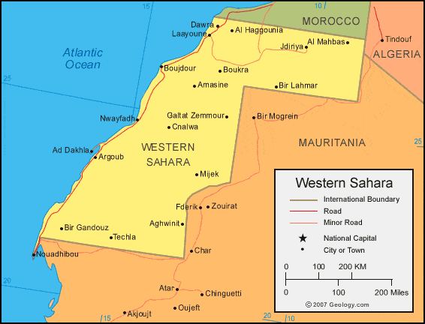
Appendix:
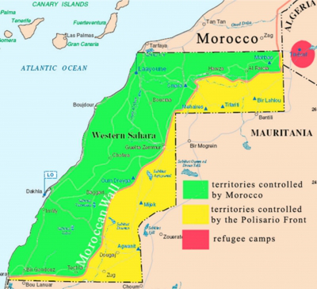
Figure 1: Western Sahara Map and Satellite Image (Source: Geology.com)
Figure 2: The demarcation of Western Sahara map . (Source; Cartographic Section Department of Field Support, 2002)

- Bibliography:
- The Western Sahara dispute drags on 27 years in Limbo. Available on: https://freedomhouse.org/blog/western-sahara-dispute-drags-after-27-years-limbo, consulted the 20th of June 2019.
- Western Sahara Profile. Available on: https://www.bbc.com/news/world-africa-14115273 ,consulted the 20th of June 2019.
- UN envoy, Peaceful solution to Western Sahara conflict possible. Available on: https://www.aljazeera.com/news/2018/12/envoy-peaceful-solution-western-sahara-conflict-181206164240438.html ,consulted the 29th of June 2019.
- A new push to resolve the conflict over Western Sahara. Available on: https://www.economist.com/middle-east-and-africa/2018/12/01/a-new-push-to-resolve-the-conflict-over-western-sahara , consulted the 23th of June 2019.
- Western Sahara dispute in dates. Available on: https://www.news24.com/Africa/News/western-sahara-dispute-in-dates-20181205 , consulted the 21st of June 2019.
- The international effects of the Western Sahara conflict . Available on: http://mediterraneanaffairs.com/the-international-effects-of-the-western-sahara-conflict/ ,consulted the 26th of June 2018.
- The Western Sahara-Morocco conflict. Available on; https://education.seattlepi.com/western-saharamorocco-conflict-5889.html ,consulted the 24th of June 2019.
- Personal envoy Western Sahara. Available on: https://dppa.un.org/en/mission/personal-envoy-western-sahara ,consulted the 29th of June 2019.
- Security council renews UN mission in Western Sahara. Available on: https://news.un.org/en/story/2018/04/1008532 ,consulted the 1st of July 2019.
- The Impact of the Western Sahara conflict. Available on: https://www.ukessays.com/essays/politics/analysing-the-impact-of-the-western-sahara-conflict-politics-essay.php, consulted the 5th July 2019.

Definition of sovereignty: https://dictionary.cambridge.org/dictionary/english/sovereignty
Definition of nationalism: https://dictionary.cambridge.org/dictionary/english/nationalism
Definition of annexation: https://dictionary.cambridge.org/dictionary/english/annex?q=annexation
Definition of Decolonization: https://dictionary.cambridge.org/dictionary/english/decolonization
Definition of Colony: https://dictionary.cambridge.org/dictionary/english/colony
Definition of ceasefire: https://dictionary.cambridge.org/dictionary/english/ceasefire
Definition of recognition: https://www.merriam-webster.com/dictionary/recognition
Definition of proclaim: https://www.merriam-webster.com/dictionary/proclaim
Definition of independence: https://dictionary.cambridge.org/dictionary/english/independence
Definition of Immobilize: https://www.merriam-webster.com/dictionary/immobilize
Who are Indigenous people: https://www.un.org/esa/socdev/unpfii/documents/5session_factsheet1.pdf
Definition of protectorate: https://www.dictionary.com/browse/protectorate
Definition of autonomy: https://dictionary.cambridge.org/dictionary/english/autonomy
Definition of self-determination: https://www.dictionary.com/browse/self-determination
Definition of petitioner: https://www.dictionary.com/browse/petitioner
The Sahrawi Arab Democratic Republic is a partially recognized state (not recognized by the UN), that claims the non-self-governing territory of Western Sahara.
Definition 3 in key terms
Definition 1 in key terms
Definition 2 in key terms
Definition 4 in key terms
Definition 5 in key terms
Definition 6 in key terms
Definition 9 in key terms
Definition 13 in key terms
Definition 14 in key terms
Definition of exodus: https://www.merriam-webster.com/dictionary/exodus
Definition of exploitation: https://dictionary.cambridge.org/dictionary/english/exploitation
Definition of imperialism: https://www.dictionary.com/browse/imperialism
Morocco has rejoined the African Union after 33 years of absence. Available on: https://qz.com/africa/898645/morocco-has-rejoined-the-african-union-but-the-western-sahara-question-remains/
Definition 19 in key terms
Definition of colonialism: https://www.dictionary.com/browse/colonialism
Definition 11 in key terms
Definition 9 in key terms
Definition 4 in key terms
Definition 8 in key terms
Definition 5 in key terms

