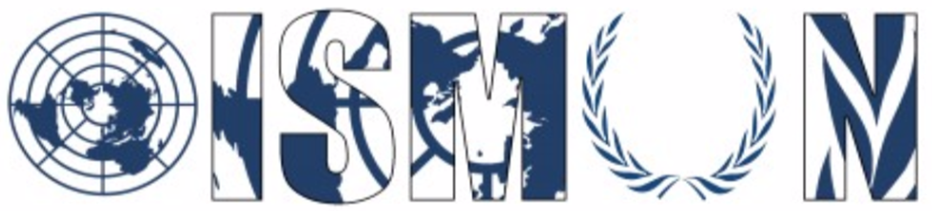

Oasis International School Model United Nations

Security Council

President: Rowayda Tarek
Vice-president: Omar Sedky

Guiding Package

Topic 1: Rebuilding Security and combatting terrorism in the MENA Region

12th annual conference OISMUN
October 2019

Table of Contents
- Abstract……………………………………………………………….....p.3
- Introduction……………………………………………………………..p.4
- Definition of key terms……………………………………………..…p.5
- Background information……………………………………………...p.6
- Major countries involved……………………………………………..p.9
- Major organisation involved………………………………………..p.12
- UN involvement……………………………………………………….p.14
- Possible solutions…………………………………………………...p.15
- Guiding questions……………………………………………………p.15
- Bibliography…………………………………………………………...p.17
- Annexes………………………………………………………………..p.19

- Abstract
Since the end of the cold war, terrorism has started to spread across the world, either protesting for new groups and ideologies, or aiming to bring back old ones that have been defeated in wars and conflicts. Although it’s a global threat, Asia and Africa are the continents under the most heat because of it.
In depth, the Middle East is the only region where terrorist groups have invaded the lands from their actual leaders. They are concentrated in Libya, Yemen, Syria and Iraq. The leading terrorist groups in these countries are ISIS, known as Daesh or ISIL, HAMAS, Hizballah, the Houthis and Al Qaeda.
However, the country that suffered an exponential setback under terrorism is Yemen, as the Houthis and Al-Qaeda forces have invaded their whole western side including the capital of Yemen. Other lands in Syria, Iraq and Libya are controlled by ISIS that are strategic strongholds with strong effects on its surroundings.
Countries have started their battles with terrorism long ago, The United States of America, for instance, has been one of the main fighters and countries committed to this cause. Therefore, victim countries who are fighting for their occupied lands have received aid and support from The US, Russia and also Saudi Arabia who is suffering from its own fight against the Houthis in Yemen.
Regardless, some countries are now recovering their strength and most noticeably Iraq who took about two thirds of the occupied lands from ISIS but still suffers from terrorist blows.

- Introduction:
Terrorism is a war in which the world is at continuous battles with violent and outlawed individuals that threaten the peace and security of the innocents. The majority of terrorist groups, unfortunately come from the MENA region or reside there, which not only makes them a global threat, but also a threat to the lands in which they are found as well as the countries that neighbor them. At the moment, the worsening instability and violence are found in four main countries of the region, which are Libya, Iraq, Yemen and Syria. Libya for instance, is in the midst of a civil war and has no primary governing body. This gave the chance to terrorist groups such as ISIS, Ansar Al-Sharia and Al-Qaeda to occupy some of its neutral lands. Another issue raised because of this instability has been human trafficking.
Not so different, Iraq has been in battle for a long time with the terrorist group ISIS and has had support from many countries in order to eliminate them. With the assistance of the coalition made by the US, they’re close to succeeding, but this leaves the threat of the terrorist group striking back with terrorist attacks. Finally, coming down to Yemen and Syria, these two countries have been the biggest victims of civil wars, proxy wars, terrorism and are suffering meanwhile from serious humanitarian crises. Therefore, solutions and assistance must be delivered to this suffering region of the world as soon as possible for the sake of its security.

- Definition of key terms
- Terrorism: The unlawful use of violence and intimidation, especially against civilians, in the pursuit of political aims.
- Foreign Aid: Foreign aid is the international transfer of capital, goods, or services from a country or international organization for the benefit of the recipient country or its population. Aid can be economic, military, or emergency humanitarian.
- Strongholds: A stronghold is a place that has been secured tightly in case of attack, or a place where a particular belief or ideology is firmly believed and staunchly defended.
- Humanitarian crisis: an event or series of events that represents a critical threat. Humanitarian crises can emerge from a range of events, spanning conflicts, natural disasters, and even infectious disease outbreaks.
- Superpower: A state that possesses military or economic might, or both, and general influence vastly superior to that of other states. A superpower is a state that cannot be ignored on the world stage and without whose cooperation no world problem can be solved.
- Solidarity: Union or fellowship arising from common responsibilities and interests, as between members of a group or between classes, peoples, etc.

- Background Information:
The war with terrorism reached its peak in 2001 with the controversial 9/11 attacks on the United States of America that have been presumed by Ossama Belladin. The world was in crisis and the USA declared war on Terrorism. Their entry into Iraq in 2003 marked how the world was going to fight this battle, which should have been together.
Sadly, countries chose otherwise and eventually created more conflicts among themselves. Civilian casualties in Iraq were numerous and USA even attacked Iraq itself declaring war on them. Later, George Bush announced in 2011 that their intelligence, announced wrong information and Iraq wasn’t supporting terrorism nor making nuclear weapons.The world didn’t take the news lightly after the casualties that exceed two million Iraqi troops and one million civilians. Iraq is now fighting terrorism relentlessly and is retaking its lands from terrorists like ISIS who were occupying a big amount of lands.
The war with terrorism in Syria debuted in 2011 and is still ongoing. It started with the civil war and the country being divided into two sides with two armies. Terrorists took advantage of the situation, started to make strong blows against both sides and were able to invade lands that are found in between. With the aid of the superpowers such as the USA and Russia, the war became more cruel and the orientation of the war against terrorism gave attention to the technological advancement of the terrorists and their advanced weaponry. Therefore, speculations have been raised regarding whether or not superpowers and advanced countries have provided support to terrorist groups for the personal benefit.
Russia has been a major contributor in the war in Syria since their official intervention in September 2015 after official request is the Syrian government for aid against the rebels. The war developed and Russian forces ambushed numerous times ISIS and Al-Qaeda bases and strongholds. Their air force and missiles had a huge role in the progression of the Syrian government.
In Yemen, the war started in 2014 with a civil war between the Houthi rebels and the Yemeni armies. In 2015, the Houthis progressed in the Yemeni territory and were able to take its capital, Sana’a, forcing the king to flee to Saudi Arabia. Thus, the conflict developed into a proxy war that created an immense humanitarian crisis in Yemen, giving a green-light for foreign countries to intervene.
Finally, the war in Libya started in 2014 and has inflicted a giant amount of damage. The country is divided into numerous parts on the terrorists, the rebels and the government same as other parties such as the Misrata. Terrorism has been getting ambushed with great force lately in Lybia as USA struck chemical missiles against terrorists in Libya same as Libyan strongholds . The war in Libya caused a lot of trouble as civilians are getting hit from all sides in the war causing the UN to announce that these strikes might lead to war crimes.
The Libyan-Russian relations have progressed in this war and their support started to come through Egypt since 2015, their military and economic support became critical of the Libyan government in their war. The position of Russia increased in importance when they decided to support the Tobruk-based council of deputies instead of the GNA backed by the UN.

- Major countries involved:
- The Republic of Yemen: Yemen is the country that has been harshly damaged from terrorism. Their whole western side has been controlled by the Houthis including their capital, Sana’a. Moreover, the humanitarian case is not getting any better as Saudi Arabia closed the bridge of aid between them, and war crimes are being committed by Saudi Arabia and the Houthis against the Yemeni population.

- The Republic of Iraq: Iraq has suffered a lot of accusations and damage because of Terrorism. The United States of America intervened and declared war in Iraq in 2003 after the events of 9/11 and had the objective of hunting down terrorist leader Ossama Belladin which wrecked the Iraqi territory. Later, terrorist groups invaded Iraqi territory after the official end of the war in 2011. ISIS and Ansar Allah entered Iraq territory and controlled nearly half of their lands. In 2017, Iraq, in cooperation with Russia, launched a full on attack and wiped out Ansar Allah and ISIL from their official lands and three quarters of the ISIL lands.

- The Syrian Arab Republic: Syria has ten countries fighting in its land. Mainly the USA, Russia, Iran and Turkey. The civil war in Syria against the rebels has developed and drained the country of its power and influence, which gave the terrorists a chance to intervene. The main terrorists in Syria are ISIL, Hezbollah and Jabhet Fateh al Sham. Russia is their main ally in this war as they are fighting the US-backed rebels and the terrorists.

- The State of Libya: Libya has been in a civil war since 2014 and gave the terrorists a chance of entry with the brutality of the war and its casualties. The main terrorist groups in Libya are ISIL, Hezbollah and Shura council. Around three quarters of the country is not under Libyan control and the situation worsens each day as more conflicts are created and both sides get strong reinforcements and anonymous military and economic aid.

- The United States of America: The official role of the United States of America has been always to fight terrorism wherever it is. Their position in this war has been always with the rebels of Libya and Syria as well as striking Houthis and ISIS forces. Their position gets controversial, sometimes and got to its peak in the incident of the chemical weapons. They don’t have a military base in the Mena region unlike Russia.

- The Russian Federation: Russia has been a main contributor in the war against Terrorism as the Syrian government officially requested their intervention to aid them in their war with terrorism and with the rebels. They also have a big role in Libya as they are beginning to supply them as much as Syria. They even made a military base in Syria assuring their control over the region.

- The Islamic Republic of Iran: Iran has been heavily accused of supporting Houthis and Hezbollah. They have confirmed supporting Hezbollah but denied the accusations of them supporting the Houthis. They have also started military and economic aid to Iraq, and helped them significantly in claiming their lands.

- Organizations Involved:
- United nations office for the coordination of humanitarian affairs (OCHA): OCHA is the section of the United Nations secretariat responsible of bringing together parties that can provide humanitarian aid and support to areas of need. It also ensures that anyone willing to help during these emergencies has a way to do so. The office works daily to provide shelter and assistance to refugees in the Middle East and North Africa.

- Organization of Islamic Cooperation (OIC): The OIC is an intergovernmental organization, second largest to the UN that represents the voice of Muslims around the world with its own charters, conventions and lectures. It constantly holds conferences aiming to solve the Muslims global problems and conditions. The secretary general Al-Othaimeen has already condemned many terrorist attacks that took place in the MENA region, such as the ones in Egypt, Saudi Arabia, Syria, etc. and announced his solidarity with the affected countries.

- Global Partnership for the prevention of armed conflict (GPPAC):The Global Partnership for the Prevention of Armed Conflict is a global network aiming to build secure and peaceful societies around the world. The network is led by civil society organizations and works with 15 different regions, including the Middle East and North Africa. While working to prevent armed conflict and violence in this region the partnership also tries to fulfill and act upon the Sustainable Development Goals (SDGs), for example by concentrating on the importance of education in areas of conflict as well as empowering the women and the youth.

- International organization for migration (IOM): The International Organization for Migration covers the support and actions related to migration in the world, including missions for missing migrants and human trafficking. Thus, migration has been an issue in the MENA region for so long and this organization has been committed to offering support and aid to the migrants there.

- UN involvement:
The United Nations has many of its departments and offices working in the Middle-East and North Africa such as the department of political affairs (DPA), the UN Refugee Agency, United Nations office for the coordination of humanitarian affairs (OCHA), etc. Topics regarding the security and safety of its populations have been raising a lot especially in the Security Council as well as the Human Rights Council. In June 28-29 2018, the first United Nations High-level Conference of Heads of Counter-Terrorism Agencies took place and had for theme “Strengthening international cooperation to combat the evolving threat of terrorism”. The situation in the Middle East is a topic that has been discussed for decades in the Security Council and numerous resolutions have been submitted to improve the living conditions in this region. Terrorism has always been one of the UN’s top priorities to deal with and eliminate.

- Possible solutions:
- The creation of the biggest coalition in UN history able to make full on attacks eliminating strategic bases and strongholds of the terrorist groups.
- Applying a Cease Fire and making a peace treaty between the sides in the civil wars of Syria and Libya until war against terrorism is resolved.
- Preventing any type of aid to any sides in civil war and only striking terrorism directly so that the civil war gets resolved

- Guiding questions:
- To what extent is the foreign aid provided in the Middle East by countries of great power such as the USA and Russia backed by more personal motives?
- To what extent Iraq’s retaking of its land from ISIS is considered a victory to their battle against the terrorist group?
- How can countries put aside their personal vendettas and fight this global threat together?
- How does the presence of terrorism in the Middle East impact the rest of the world?
- To what extent foreign intervention in the Middle East may have been a cause to more conflicts?

- Useful Links:
- JAMESTOWN, Ressources Website for global research and analysis, available on: https://jamestown.org/
- Council of foreign affairs global conflict tracker, available on: https://www.cfr.org/interactive/global-conflict-tracker/?category=usConflictStatus
- CRISISGROUP, news website, available on: https://www.crisisgroup.org/
- Official website for the Organization of Islamic Cooperation, available on: https://www.oic-oci.org/home/?lan=en

- Bibliography:
- ANONYMOUS, “Iraq Listed Terrorist Group and Humanitarian Crises”, [consulted: 01/07/2019], available on: https://www.charityandsecurity.org/country/iraq
- ANONYMOUS, “Libya: Listed Terrorist Groups and Humanitarian Crises”, -[consulted: 22/06/2019], available on: https://www.charityandsecurity.org/country/libya
- ANONYMOUS, “War in Iraq Begins”, November 24 2009 - [consulted 23/06/2019], available on: https://www.history.com/this-day-in-history/war-in-iraq-begins
- AUGUSTIN Adam, “Iraq war”, [consulted: 23/06/2019], available on: https://www.britannica.com/event/Iraq-War
- CURTIS Marc, “How West’s War in Libya has Spurred Terrorism in 14 countries”, May 3 2019 - [consulted: 22/06/2019], available on: https://www.middleeasteye.net/opinion/how-wests-war-libya-has-spurred-terrorism-14-countries
- GBERIE Lansana, “Forgotten War: A Crisis Deepens in Libya but where are the Cameras”, [consulted: 24/06/2019], available on: https://www.un.org/africarenewal/magazine/december-2017-march-2018/forgotten-war-crisis-deepens-libya-where-are-cameras
- JENKINS Brian Micheals, “The Role of Terrorism and Terror in Syria’s Civil War”, November 20 2013 - [consulted: 23/06/2019]. available on: https://www.rand.org/pubs/testimonies/CT402.html
- MIRONOVA Vera, “The New Face of Terrorism 2019”, January 1 2019- [consulted: 22/06/2019], available on: https://foreignpolicy.com/2019/01/01/the-new-face-of-terrorism-in-2019/
- OMELICHEIVA Mariya, “Russia’s Counter-terrorism Policy: Variations on Imperial Theme”, 2009 - [consulted: 01/07/2019], available on: http://www.terrorismanalysts.com/pt/index.php/pot/article/view/61/html
- PERLO-FREEMAN Samuel, “Who is arming the Yemen War? (and is anyone planning to stop?)”, February 28 2018 - [consulted: 02/07/2018], available on: https://sites.tufts.edu/reinventingpeace/2018/02/28/who-is-arming-the-yemen-war-and-is-anyone-planning-to-stop/
- PUSZTAI Wolfgand, “What Makes Libya the Perfect Place for Terrorists”, March 15 2015 - [consulted: 22/06/2019], available on: https://www.ispionline.it/it/pubblicazione/what-makes-libya-perfect-place-terrorists-12894
- Report by the UN High Commissioner for Refugees, “Update of UNHCR’s operations in the Middle East and North Africa”, September 20 2018 - [consulted: 03/07/2019], available on: https://reliefweb.int/report/syrian-arab-republic/update-unhcr-s-operations-middle-east-and-north-africa-20-september-2018
- STEPHENS Hampton, “The Syrian Civil War is Russia’s Problem Now”, February 11 2019 - [consulted: 02/07/2019], available on: https://www.worldpoliticsreview.com/insights/25712/the-syrian-civil-war-is-russia-s-problem-now
- WINTOUR Patrick, “Yemen Civil War: The Conflict Explained”, June 20 2019 - [consulted: 23/06/2019], available on: https://www.theguardian.com/world/2019/jun/20/yemen-civil-war-the-conflict-explained

Annexes:

- This is the map of Syria right now and the controlling forces of each region of the country from terrorist groups to government control to UN control.
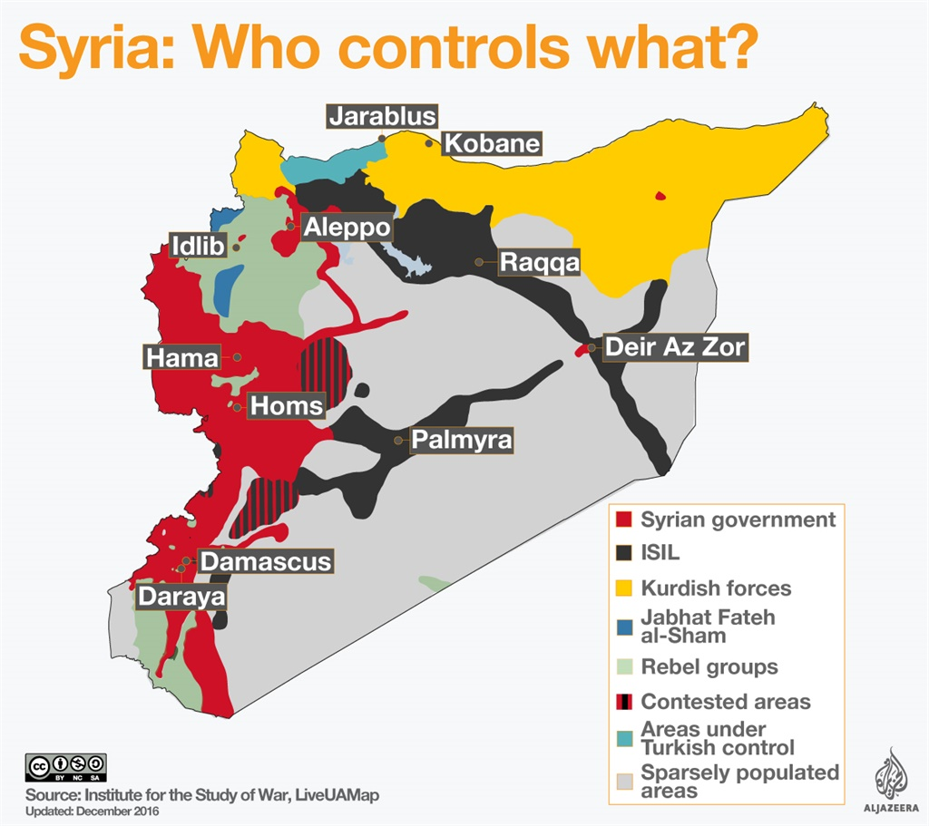
- This is the map of Yemen that also shows who are the controlling forces of each region and shows the important cities such as Sanaa the capital.
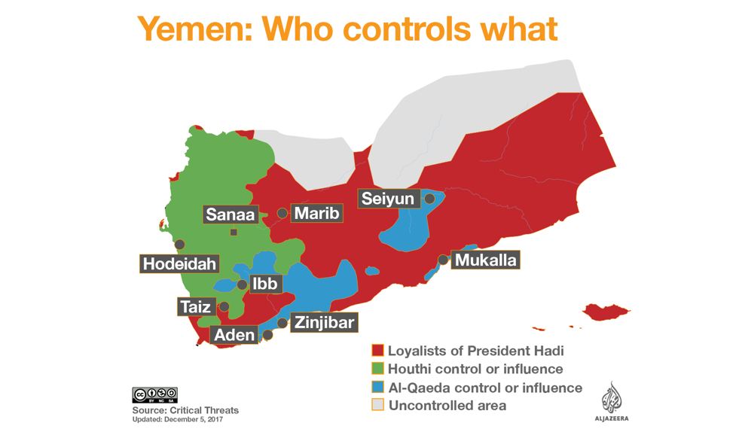
- This is the map of Iraq right now after their campaign against terrorism to take back their lands that shows the amount of land controled by each side. 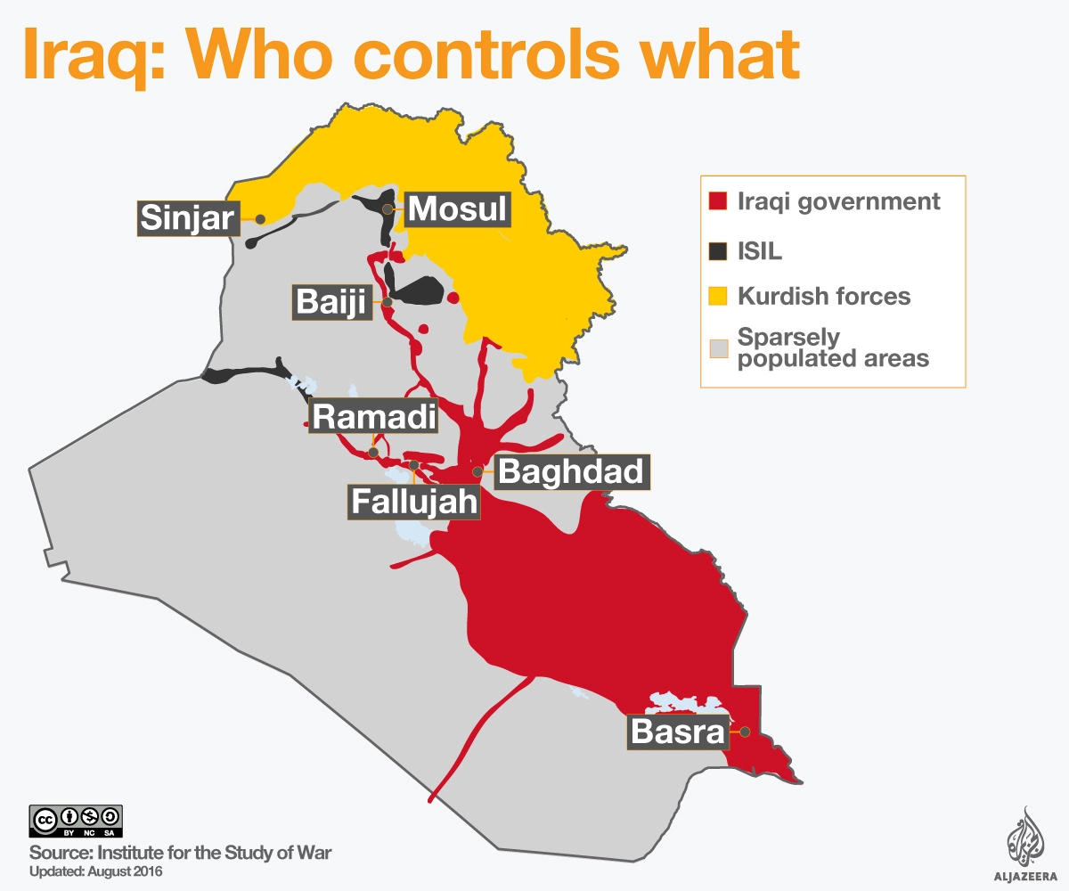

- This is the map of Libya right now showing the controlling power of each region and their leaders.
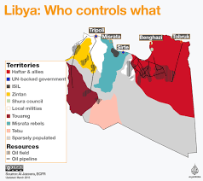

WILLIAMS Victoria, Foreign Aid, available on: https://www.britannica.com/topic/foreign-aid
Your dictionary, Stronghold, available on: https://www.yourdictionary.com/stronghold
Characteristics of humanitarian crises, available on: https://www.futurelearn.com/courses/health-crises/0/steps/22887
MUNRO André, Superpower politiacal science, available on :https://www.britannica.com/topic/superpower
Definition: Solidarity, available on: https://www.dictionary.com/browse/solidarity

