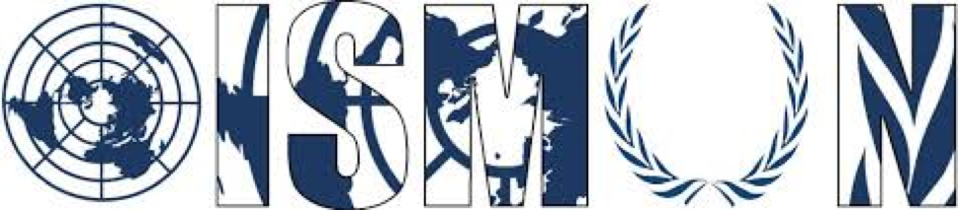

OASIS INTERNATIONAL SCHOOL MODEL UNITED NATIONS

General Assembly Fourth Committee :
Special Political and Decolonization

President Ali Salawi
Vice-President Raghda Gad

Guiding package

Topic (2): The Kashmir conflict

12th Annual OISMUN conference

Table of Contents
- Abstract
- Introduction
- Definition of Key Terms
- Background Information
- Major Countries Involved
- Major Organizations Involved
- UN Involvement
- Possible Solutions
- Guiding Questions
- Bibliography

- Abstract :
The disputes over the Kashmir territory dates back to 1947. The conflict began after the decolonization of India, a time where the religious confrontations led to the division of India and the creation of Pakistan. The issues occured in states that exist between the two newly formed countries. These states would either claim independence, or join either Pakistan or India. However both India and Pakistan are disputing on which princely States each country would claim, and in that case Kashmir is the main focus.
Kashmir’s is located in the Himalayan mountains, and it shares borders with Indian States. That factor allows them to join either Pakistan or India. Jammu and Kashmir is consisted of 2 divisions: Jammu and the Kashmir Valley (administered by India) which is divided further into 22 districts.
Due to the events that occurred in 1947, when Pakistan had sent troops into Kashmir, Hari Singh, the ruler of Kashmir, sought help from the Indian government. The struggle had continued and three wars occurred between the two parties. Even though the UN had interfered and sought the removal of military troops and a ceasefire, the respect of those conditions remained temporary and the dispute resumed.
Nowadays protests continue to rise, and many violent confrontations occur. Civilians are exposed to high levels of violence, with events such as detention, hostage, and torture.

- Introduction
Through the 20th century, colonies got decolonized after fighting for their independence. However, the process to obtain true independence and rebuild a nation is full of obstacles. Some of those obstacles including economical status, international relations and social differences and disputes.
Many nations have struggled to maintain peace due to the religious conflicts that occur. The unity of the population is often impossible and the religious disputes can escalate into a war. India was one of those countries that has struggled with religious disputes. Therefore as a temporary end to that conflict, it got divided and Pakistan was created.
However, that wasn’t the end of the conflict between India and Pakistan. This division of land had left many regions with an undefined future. As a result, territorial disputes emerged between the two nations. Each country aimed to expand its territory, to the advantage of more resources. The disputed territory in our case is Kashmir, a region with extreme geographical importance which increased its importance and aggravated the conflict between India and Pakistan.

- Definition of key terms :
- Princely states: a state under a local or regional ruler in a subsidiary alliance with the British Raj.
- Suicide bombings: A nation’s attempt to be politically independent.
- Skirmish: to take possession of an area of land without permission, with the use of force
- Decolonization: the process in which a country that was previously a colony becomes politically independent.
- Colony: A country or an area that is controlled by a superior and more powerful country.
- Line of Control: A line which does not constitute a legally recognized international boundary, but is the de facto border.
- Bilateral : Involving two parties or countries.
- Ceasefire: An agreement between two parties to stop fighting in order to discuss peace arrangements.
- Accession: it is the acknowledgement by a state of the status by other government that is in control of a state
- The Kashmir unrest: A series of violent protests in the Kashmir Valley between the year 2017 and the year 2017
- Refugees: A person who has been forced to leave their country in order to escape war, persecution or natural disaster.
- Plebiscite: The direct vote of all people of all the people entitled to vote, on an important question; such as a change in the constitution.
- Parity: the state or quality of being equivalent and equal
- Militant: Someone who is vigorously active, combative and aggressive, in order to support a cause.

- Background Information
India was a British colony from the 17th century until the 20th century. When it obtained its independence, religious conflicts occurred and disputes took place between Hindus and Muslims. That concluded in the separation of India and the creation of Pakistan. Therefore this division had left 550 princely states, including Kashmir, that could either join India or become independent states.
Kashmir resides a big importance due to its geographical position, specifically its borders which it shares with Afghanistan, that consists of a pathway from South Asia to central Asia. Through that connection with Central Asia it facilitates the reach to Europe. It also plays a geographical component to the China-Pakistan Economic Corridor (CPEC) and the Belt Road Initiative (BRI)
Central Asia consists of a land with massive amounts of sources of energy deposits and other natural resources such as : oil, natural gas, uranium, gold. Also, the land’s consumer market with a population that is almost 70 million. As a result, the geographical position to Kashmir that gives access to Central Asia via Afghanistan is extremely significant.
Due to the fact that the ruler of Kashmir was Hindu while most of the population were Muslim, this led to taking a neutral position and Mahraja Hari Singh didn’t choose which country to join.
The path to independence became difficult when in October 1947 Pakistan sent muslim troops to invade the capital Srinagar. The ruler of Kashmir seeked the military assistance of the Indian government. Consequently, he signed the Instrument of Accession, ceding Kashmir to India on October 26.
India and Pakistan’s first war over Kashmir began in 1947, and India had referred the disputes to the United Nations. Consequently on August 1949, the United Nations had asked Pakistan to withdraw its troops, following which India would do the same. However, Pakistan believed that India would not respect the resolution and therefore did not remove their troops. On January 1949, a ceasefire was agreed upon, while 65% of the territory was under Indian control .
Originally the intended plan is to clear the land of foreign forces and after a plebiscite will take place and the Kashmir people will decide if they will be independent or join either one of the two countries. India was reassured to win the plebiscite as Sheikh Abdullah, an influential Kashmir leader, was on its side. An emergency government was formed on The 30th of October 1948 with the Prime Minister Sheikh Abdullah. In 1957, Kashmir had been formally incorporated into the Indian Union, with its status under article 370 of India’s constitution.
The conflict resumed in 1965, that had ended with the endorsement of a ceasefire and a bilateral agreement (Tashkent) . However the death of the Indian Prime Minister has triggered the conflict, causing the third war to commence in 1971, that resulted in the formation of Bangladesh. In 1972, they signed the Simla Agreement which renewed the promises of Tashkent.
Armed conflicts continue to occur, on The 14 November 2016, 7 Pakistani soldiers are killed at the Line of Control. In February 2019, one of the deadlist acts in years took place, a suicide bombing occured that caused the death of 40 people. Protests erupt once more in 2017 with the killing of a militant leader.

- Main countries involved :
- Islamic Republic of Pakistan: Pakistan has been created after the division of India post its decolonization in the 20th century. Due to the conflicts between the budhists and the muslims, Pakistan has been created as a Muslim territory. It opposes India’s claims over Kashmir, which resulted in the emergence of rebel movements, such as the rebel in 1947 that took over the western part of Kashmir. However, Pakistan would agree upon a bilateral agreement but with the assurance that India will back out of the territory as well.
- Republic of India: India is the second party of the conflict, as it believes that it has the rightful claim over Kashmir. It believes that Kashmir is an integral part of India. India doesn’t accept the two-nation agreement, therefore does not believe in Pakistan’s formation. In 2010, the Prime Minister of India had stated that it is willing to grant autonomy to the region but with the purview of Indian constitution. Evenmore, the state of Jammu and Kashmir had obtained its autonomy under article 370 of the Constitution of India.
- The People's Republic of China: China is involved in the matter as a third party as it also claims its right over a part of the Kashmir region. As China recognizes Aksai Chin, a territory in Kashmir, as a part of their nation. Evenmore it did not accept the boundaries of the state of Kashmir and Jammu. And it had settled its disputes in 1963 under the Trans Karakoram Tract with Pakistan.

- Main organizations involved:
- Jammu Kashmir Liberation Front (JKLF): It is a political organisation that is active in both parts of Kashmir, the Indian Kashmir and Pakistani Kashmir. It was founded by Amanullah Khan to be a military wing of the Plebiscite Front. Until 1994 it had been an active militant organisation. In 1977 it was named JKLF in England. Events that occured in 1994 resulted in the division of JKLF into two organisations with the same name. JKLF in the Indian region of Kashmir (the Kashmir Valley) had declared indefinite ceasefire, aiming to make Kashmir an independent state. However, the other JKLF in the Pakistan area (the Azad Kashmir) did not agree with the independence of Kashmir. However the JKLF in the Kashmir Valley is not supported by India, as it had been banned by Indian government under anti-terror law in March 2019.
- All Parties Hurriyat Conference (APHC); A political, social and religious alliance of 26 organizations. It was formed on 9 March 1993, as a united front to raise the cause of the removal of Indian troops in the Kashmir territory (Kashmiri separatism). According to the Hurriyat Conference, India’s control of it is not justified. It also supports the Pakistani claim. The organisation views itself as the main representative of the Kashmiri people. Their main role was to mobilise public opinion against Indian security forces.
- The World Bank: In 1948, the President of the World Bank Eugene Black had offered the help to solve the dispute over the water control. At that time India had shut of Canals which damaged Pakistanian crops. Therefore it made both parties sign the Indus Waters Treaty in September 1960.

- UN involvement:
The United Nations had played an important role in order to maintain peace in Jammu and Kashmir. The first time that the UN interfered in the matter was when India took it to the UN in 1947, that had passed resolution 29 in 1948.
The United Nations Commission for India and Pakistan (UNCIP) had been established, with the goal of investigating the issues and finding an agreement between the two countries.
Those events were followed with the war that took place in 1947, and a ceasefire was agreed upon. Also, the United Nations Military Observer Group for India and Pakistan (UNMOGIP) had been established to monitor the agreed upon cease-fire line.
In 1948 a solution had been proposed in a resolution for Pakistan to withdraw it troops and when that is completed India should remove its forces as well. However that resolution was accepted by India and was rejected by Pakistan.
In February 2019, Pakistan’s foreign minister had appealed to the UN Secretary General in order to help ease the tension between Pakistan and India. As it has escalated into suicide bomb attacks in the Indian part of Kashmir, that India had blamed it on Pakistan.

- Possible solutions:
- The division of Kashmir into two states, the north administered by Pakistan and the south India
- Establishing elections that decide if Kashmir shall become an independent state
- Singing a peace treaty that prevents any further military confrontations

- Guiding questions:
- Should Kashmir become an independent state, and under what ruling?
- Is the division of Kashmir a solution to the dispute?
- How can the UN’s neutral position help in the negotiation between both parties?
- Would Pakistan or India agree on turning Kashmir independent?
- What measures can be taken to end the violent attacks?
- What bilateral agreement can be reached between Pakistan and India?
- How can a treaty reassure no further armed conflicts will take place?
- Useful links
- The Kashmir conflict: How did it Start. Available on: https://www.nationalgeographic.com/culture/2019/03/kashmir-conflict-how-did-it-start/
- Why Kashmir means so much to both India and Pakistan. Available on: https://edition.cnn.com/2016/09/30/asia/kashmir-explainer/index.html
- Solving the Kashmir conflict. Available on: https://www.wrmea.org/002-august/solving-the-kashmir-conflict-india-and-pakistan-the-worlds-most-dangerous-place.html
- Kashmir fast facts. Available on: https://edition.cnn.com/2013/11/08/world/kashmir-fast-facts/index.html
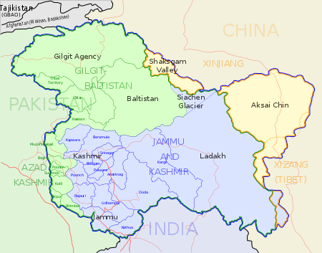
- Appendix
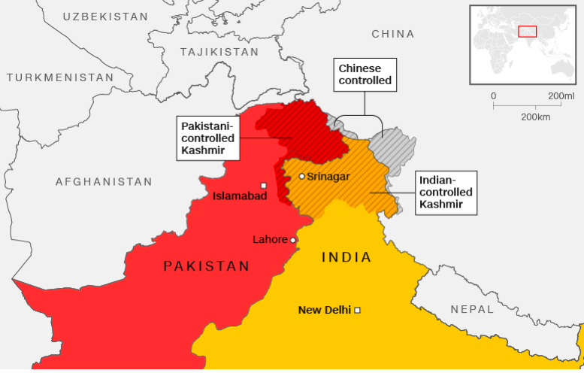
Figure 1 : Map showing districts of Jammu and Kashmir (shown in blue). Source; University of Texas Map library
Figure 2 : Map showing the different areas of control of Kashmir. Source: CNN

- Bibliography:
- The Kashmir conflict how did it start. Available on : https://www.nationalgeographic.com/culture/2019/03/kashmir-conflict-how-did-it-start/ , consulted the 23rd of June 2019
- Kashmir conflict is not just a border dispute between India and Pakistan :. Available on http://theconversation.com/kashmir-conflict-is-not-just-a-border-dispute-between-india-and-pakistan-112824 , consulted the 23rd of June 2019
- The Kashmir conflict explained. Available on: https://www.aljazeera.com/news/2019/02/kashmir-conflict-explained-190227145750670.html , consulted the 24th of June 2019
- A brief history of the Kashmir conflict. Avaialble on: https://www.telegraph.co.uk/news/1399992/A-brief-history-of-the-Kashmir-conflict.html, consulted the 25th June of 2019
- Kashmir, why India and Pakistan fight over it. Available on: https://www.bbc.com/news/10537286 , consulted the 25th of June 2019
- Kashmir encyclopedia . Available on: https://www.britannica.com/place/Kashmir-region-Indian-subcontinent, consulted the 29th of June 2019
- Can the Kashmir conflict ever be resolved. Available on: https://www.youtube.com/watch?v=Dmh8wXfgJto , consulted the 2nd of July 2019.
- The Kashmir conflict in under 4 minutes. Available on: https://www.youtube.com/watch?v=GbtyfvnGafk , consulted the 5th of July 2019.
- Kashmir: conflict and peace. Available on: https://www.peaceinsight.org/conflicts/kashmir/ , consulted the 8th of July 2019.

Definition of princely state: https://www.definitions.net/definition/princely+state
Definition of suicide bombings: https://www.merriam-webster.com/dictionary/suicide%20bomber
Definition of Skirmish: https://www.merriam-webster.com/dictionary/skirmish
Definition of Decolonization: https://dictionary.cambridge.org/dictionary/english/decolonization
Definition of Colony: https://dictionary.cambridge.org/dictionary/english/colony
Definition of Accession:https://www.merriam-webster.com/dictionary/accession
Definition of Bilateral: https://www.merriam-webster.com/dictionary/bilateral
Definition of Parity: https://www.merriam-webster.com/dictionary/parity
Definition of Line of control: https://www.thefreedictionary.com/Line+of+Control
Definition of ceasefire: https://www.thefreedictionary.com/ceasefire
Kashmir: Season of unrest: https://time.com/4423531/kashmir-india-conflict-srinagar/
Definition 1 in Key terms.
Definition of Plebiscite: https://www.merriam-webster.com/dictionary/plebiscite
What is a Refugee : https://www.unrefugees.org/refugee-facts/what-is-a-refugee/
Map in Appendix
Definition 12 of key terms
Definition 4 of Key Terms
Definition 5 of Key terms
Definition 7 of Key terms
Definition 8 of Key terms
It is a collection of infrastructure that are currently under construction through Pakistan. The value of the project consists of 62$ billion in 2017.
A global development strategy that China adopted, which involves infrastructure development in 152 countries.
Definition 6 of Key terms
Definition 14 of key terms
Definition of militant: https://www.oxfordlearnersdictionaries.com/definition/english/militancy

