OASIS INTERNATIONAL SCHOOL MODEL UNITED NATIONS

General Assembly

President: Nour El Meery
Vice-President: Youssef El Massry

Guiding Package
Topic: Considering Systems of Reintegration for Ex-Prisoners

11th Annual OISMUN conference
Table of contents
- Abstract………………………………………………….…………………….…………2
- Introduction………………………………….…………………………...………………3
- Definition of key terms………………………………………………………….……….4
- Background information………………………………………………………………...6
- Major countries and organizations involved…………………………………..……...8
- UN involvement………………………………………………….………………………9
- Possible solutions……………………………………..………………………..……..10
- Guiding questions……………………………………………………………..……….10
- Useful links………………………………………………….…………..……………...11
- Bibliography………………………………………………….………….……………..12

- Abstract:
Society today is very complex, as the years go by, crimes are committed and rules are altered. Bending the rules of the country you are in has the consequence of getting arrested as well as spending a certain period of time in jail. Once this person is released, they are not completely free, or at least it depends on the location in which they got arrested. Today, a former prisoner in some countries will be given a list of demanded things they have to complete with the passage of time. This technique is used in order for the individual to become a productive member of society instead. Norway focuses on rehabilitating their prisoners in order to work, they believe that work is the is the key to get out of a criminal pattern. After conviction, five years later there’s a lower risk of convicts committing new crimes by 27 percent. In comparison to those who are given lenient penalties such as community service or probation. Other countries don’t agree with the same mentality as they have different regulations and systems of social reintegration of inmates. Addressing an issue like this can be controversial if we are trying to make it universal as to how ex-prisoners should be treated after release which is why the United Nations is working towards finding solutions that will fit with every country’s systems.

- Introduction:
Reintegration refers to the process of rehabilitation of the prisoners and their re-entry into the society. Regarding the fact that the prison is a society within society which means that the prison’s has a completely different set of social guidelines than the civil one. As a result, returning to the outside world is not a simple task because a person must readapt to it. The social reintegration of prisoners is an integrated part in the efforts of reducing recidivism because they are rehabilitation tools for the prisoners that make them able to live again in a society, which is very healthy for both parties. A majority of convicted offenders have at least one prior conviction, among recidivists nearly 75 percent have multiple prior convictions, which makes it imperative that governments and communities develop effective tools and solutions that will assist ex-prisoners to reintegrate into the society and avoid further criminality.

- Definition of key terms:
- Reintegration: “the action or process of integrating someone back into society, restoring someone back into civil unity”
- Convicts: “another term used to describe prisoners”
- Felon: “a person who has committed a felony (a felony is a grave crime that has serious damage)”
- Rehabilitation: “the action of restoring someone that has been damaged to health or normal life through training and therapy after imprisonment”
- Inmates: “a person that is residing and confined in a hospital or prison”
- Supermax: “a high-security prison that is usually intended for dangerous prisoners”
- Incarceration: “synonym to imprisonment, incarceration is the state of being confined and captivated in prison”
- Penalty: “punishment or sanction imposed for breaking the law or any legal activities”
- Recidivism: “the tendency of a convicted criminal to reoffend”
- Lenient: “a punishment of mild and tolerant effect by authority”
- Probation: “the act of monitoring through the process of testing or observing the character of a person who is new to a role or job, thus prisoner probation is when you monitor the ex-prisoner in his every day life after his release”

- Background information:
Social integration has a huge importance in different fields, such as the economic field, the social field and the psychological field. It’s important economically as the prisoner’s employment counts as the first step in most of the social reintegration systems as the studies show that: steady employment is one of the best guarantees against recidivism, and their employment the man power of the country. Some European countries use different tools to reintegrate them like for example, the Republic of Turkey that obliges companies to employ more than 50 staff employees with the addition of including a certain percentage of ex-prisoners among their staff. If companies do not fulfil this obligation, then they must pay a fine to the Ministry of Labor and Social Security. In Finland, some of the prisoners who are nearing the end of their sentences, undertake ‘civilian work’, for which they are paid a normal market rate. The social importance of reintegration is that these systems aim to change the lifestyle of the prisoners, from an aggressive style to one that is reduced so that they can adapt to society. This is very healthy and important for the community. Finally, addressing its psychological importance, the systems of reintegration helps the prisoner to adapt to the environment and ignore all of the criminal thoughts they have in mind which is very once again to his benefit. There are many projects that were made to treat the problems related to this topic. A project, “Yellow Ribbon Project” was created in 2004 with three goals:
- Generate awareness of the difficulties ex-offenders face after release.
- Encourage acceptance for ex-offender’s form families and the community as they return to free society.
- Inspire public action to support their reintegration.
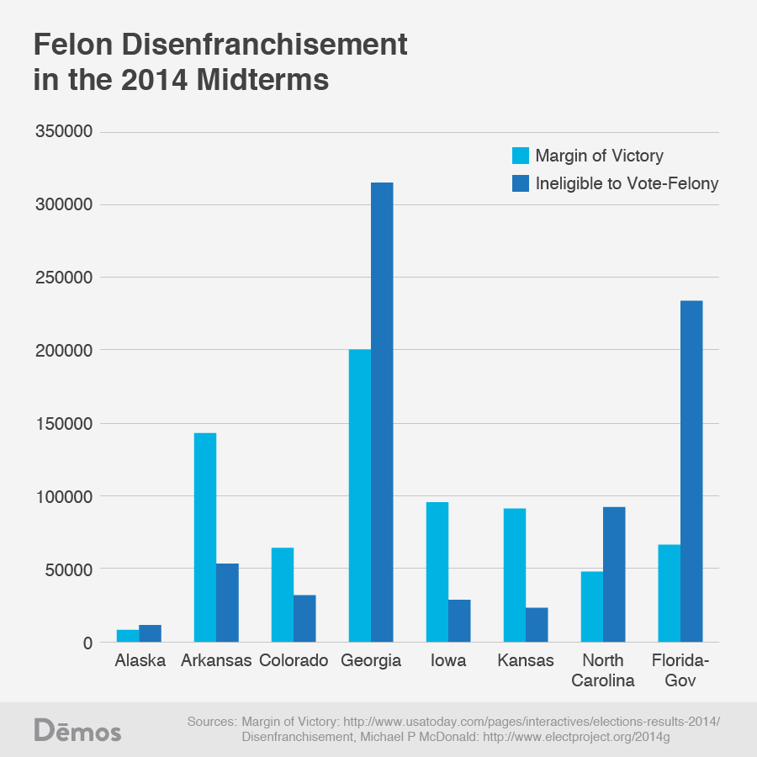
Some countries will go as far as prohibiting ex-prisoners to vote as presented in the graph. Felon disenfranchisement is excluding people from voting; however, they should be ineligible to vote due to conviction of a criminal offense. Normally, those who are restricted of voting are those who are released from a more serious class of crimes (felonies or crimes that residue to incarceration/ imprisonment for more than a year). This is a study to show how the states of the United States of America treat their ex-prisoners when it comes to their voting rights.

- Major countries and organizations involved:
- Major countries involved:
- The United States of America: they have correctional supervision on their ex-cons. In the past 30 years, the US has encountered an increase of incarceration by 2.25 million prisoners. Most of their ex-cons are under parole or probation. They have also created a project called H.O.P.E (helping offenders pursue excellence) so that they tend to their housing, educational/ employment needs. Ninety seven percent of offenders in jail today will be released and then return to the communities they came from as well as 30% of adult offenders go back to jail 6 months after release.
- The Commonwealth of Australia: Australia is one of the biggest countries that studies their prisoners after release. It’s also known for having a huge number of poor living state for ex-prisoners, most of them turn homeless and there is high recidivism. Ex-prisoners are not well accommodated and this results to poor lifestyles and health. However, when released they are expected to live successfully which is why Australia is working on finding an efficient system. Because of their failed reintegration, 58% of prisoners are in jail for their second time.
- Canada: ex-offenders released from prison often face some sort of anxiety because they are discriminated for who they are (ex-inmates). They are rejected from work, social relationships with new people out of fear of recidivism. They are isolated and thus need mental help. Canada offers certain programs for those who are mentally unstable. They are then incarcerated in another facility.
OECD (Organisation for Economic Co-operation and Development) countries have a high and rapid increasing number of releases which makes them seek for ways to reintegrate them to their community. They believe that the housing of these people is extremely important and vital for rehabilitation.
Other countries refuse to let ex-prisoners vote such as Bulgaria, Estonia, the Russian Federation…etc.

- Major organizations involved:
- United Nations Educational, Scientific and Cultural Organization: UNESCO is an organization that works alongside the United Nations. It is helping ex-offenders in finding a job/ education. It helped multiple countries’ prisoners to re-enter their society like Senegal. They have programs available to ex-prisoners so they can feel like they have the freedom to do what a normal citizen has the right to do.
- Quaker Council of European Affairs: this council has made a lot of meetings discussing the statistic of European countries, prisoner rehabilitation and their re-entry into society. They study the cases, they find the root of the problem and then start taking action towards ending recidivism. They help give them a place to live, they qualify them for their job, they try to make reports detailed with all cases in order to take the necessary actions towards the issue.

- UN involvement:
In an attempt to solve this issue, the United Nations Office of Drugs and Crime created a toolkit for reintegration called “custodial and non-custodial measures of social integration: criminal justice assessment toolkit” in which they introduced the issue as well as tried to find a or multiple solutions for it. As well as an introductory handbook about the prevention of recidivism and the reintegration of offenders that also introduces the topic, they discussed different strategies that can prevent or reduce recidivism, give reasons to invest in the social reintegration systems, gave examples of successful reintegration programs that are already established and talked about specific cases of reintegration like the child offenders as well as women and group offenders. This introductory was agreed upon in the UNODC committee of the UN.

- Possible solutions:
- Creating a facility where they train ex-prisoners how to find a job, how to encounter and deal with those who are afraid of them.
- Assessing a counselor, psychologist or psychiatrist that follows up with the ex-prisoner’s lives to make sure they are stable for the first 6 months (time depending on how often prisoners fall back into incarceration after their re-entry).
- Treating prisoners like normal people (Norway’s system).
- Making rules apply to work environments where they should accept a minimum of ex-prisoners.
- Building specific households/ living systems where the former convicts can settle in for the first couple of months until they can find a stable home.

- Guiding questions:
- How can the General Assembly Committee ensure a safe reintegration system for the ex-prisoners?
- How can we create a system of reintegration for the ex-prisoners?
- What are the components of a reintegration system?
- Do you think the same system should be applied to all countries?
- Do you think ex-prisoners should be held captive in another institution (an after prison) where they receive their rights but don’t deserve complete freedom for their crimes?
- Should these ex-convicts be monitored for a certain period of time, forever or not at all?
- Do you think all ex-prisoners should receive the same treatment or should the system become more strict based on the extremity of their felony?

- Useful links:
- THE QUAKER COUNCIL FOR EUROPEAN AFFAIRS, available on: https://www.cep-probation.org/uploaded_files/rprt-reintegration-full-en-may-2011.pdf, consulted on the 27/6/2018.
- UNITED NATIONS GENERAL ASSEMBLY RESLUTION, available on http://www.un.org/documents/ga/res/45/a45r122.htm, consulted on the 27/6/2018.
- UNITED NATIONS RESOLUTION ON PRISONER TREATEMENT, available on https://files.eric.ed.gov/fulltext/ED342888.pdf, consulted on the 27/6/2018.
- SAGE JOURNALS, available on: http://journals.sagepub.com/doi/abs/10.1177/0306624X07309757?journalCode=ijoe, consulted on the 24/6/2018.
- PUB MED, available on: https://www.ncbi.nlm.nih.gov/m/pubmed/18063748/, consulted on the 24/6/2018.
- PUBLIC SAFETY CANADA, available on: https://www.publicsafety.gc.ca/cnt/rsrcs/pblctns/scl-rntgrtn/index-en.aspx, consulted on the 24/6/2018.

- Bibliography:
- The University of Bergen Studies, available on https://www.uib.no/en/news/100126/norwegian-prisons-rehabilitate-criminal-offenders, consulted on the 27/6/2018.
- The Guardian, available on https://www.theguardian.com/society/2012/may/18/halden-most-humane-prison-in-world, consulted on the 27/6/2018.
- United Nations Peacemaker, available on https://peacemaker.un.org/thematic-detailed/social-reintegration, consulted on the 27/6/2018.
- United Nations Office on Drugs and Crime, available on https://www.unodc.org/documents/justice-and-prison-reform/cjat_eng/4_Social_Reintegration.pdf, consulted on the 27/6/2018.
- Penal reform, available on: file:///C:/Users/Nour%20El%20Meery/AppData/Local/Microsoft/Windows/INetCache/IE/UE8990CQ/Reintegration-AMIMB-conference-291012.pdf, consulted on the 24/6/2018.
- Dublin institute of technology, available on: file:///C:/Users/Nour%20El%20Meery/AppData/Local/Microsoft/Windows/INetCache/IE/TMAO8DXN/Lived%20Experiences%20of%20Reintegration_%20A%20Study%20of%20How%20Former%20Prisone.pdf, consulted on the 24/6/2018.
- Edith Cowan University, available on: file:///C:/Users/Nour%20El%20Meery/AppData/Local/Microsoft/Windows/INetCache/IE/0PPSC8WO/Prisoner%20reentry%20and%20reintegration%20_%20perspectives%20of%20the%20women%20in.pdf, consulted on the 24/6/2018.

