OASIS INTERNATIONAL SCHOOL MODEL UNITED NATIONS

Economic and Social Council

President: Rafy Anwar

Vice-president: Nour Amin

Guiding package

Topic (2): Discussing the Socio-economic Repercussions Induced by Religious Intolerance

11th Annual OISMUN conference
Table of Contents
- Abstract
- Introduction
- Definition of Key Terms
- Background Information
- Major Countries Involved
- Major Organizations Involved
- UN Involvement
- Possible Solutions
- Guiding Questions
- Bibliography
- Annexes
- Abstract

Religion is one of the many aspects that define the person’s beliefs. It can come in any shape and form. There are an estimated 4,200 different religions in the world, and these can be categorized into several main religions. Religious intolerance is the act of disrespecting or not respecting an individual’s rights concerning their religious beliefs that are different from your own. This type of discrimination has been present for years as time goes by and the years develop.

It depends on a lot of aspects to describe whether a country is considered religiously tolerant or intolerant. These elements may consist of the political aspect (government and law), social, economic and environmental context. We still find religions that are not yet accepted by nations. Religious groups that are censored and are deprived of their rights due to religious intolerance. Religious intolerance can lead to catastrophic issues and consequences.

Economic consequences are severe and can damage economic development. Tourism, the main industry of many countries around the world, directly relates to national peace. In addition to business instability, if the hiring procedures are affected by an intolerance of religion, it creates an automatic decrease in economic output. On the other hand, between 2008 and 2012 the twelve most religiously diverse countries were found to have above average economic growth. This means that religiously tolerant countries have a higher economy.

Social consequences of religious intolerance exist in forms of discrimination as well as xenophobia. Furthermore, reported hate crimes against religious minorities rose by 86 % globally from May 2016 to May 2017, with Muslims, Christians, and Jews being main targets across the world. Countries with higher populations of migrants, have also seen massive increases in reports of hate crimes, leading to questions of instability and social injustice.

- Introduction

In a world that has become increasingly interconnected, it is more important now than ever for countries to promote the tolerance of religious differences that exist within and between them. Whether the reason relates to building stronger economies or building stronger societies, religious tolerance benefits the international community. While some countries have embraced this idea of religious tolerance to promote the advancement of the citizens, others have struggled with the actual implementation of practices that combat religious intolerance and its effects on both the economy and society as a greater whole.

The future of modern society depends on religious tolerance. Because of the world’s important economic interdependence, business growth relies on peaceful relationships between countries of different religions, while social advancement is dependent on the understanding and acceptance of religious diversity. The world has suffered from many catastrophic conflicts, that are mainly caused by the growing anxieties and prejudice of religious minorities.

- Definition of Key Terms

- Religious Intolerance: is the act of disrespecting or not respecting an individual’s rights concerning their religious beliefs that are different from your own.
- Religious Tolerance: is accepting and supporting individual’s right to freedom to their own religious beliefs.
- Socio-economic: related to or concerned with social and economic factors.
- Repercussions : an effect or result of some sort of event of action
- Xenophobia: Hatred and fear towards someone or something different.
- Minority group: are a group of people differentiated from the social majority of which it is a part of.
- Prejudice: a certain dislike formed beforehand with no knowledge, thought or reason
- Background Information

Religious intolerance is prejudice against another's religious beliefs or practices or lack thereof. It’s not just the idea that its own beliefs and practices are correct and any contrary beliefs are incorrect. Religious intolerance is when a group (like a society, religious group, non-religious group) specifically refuses to tolerate contrary practices, persons or beliefs on religious grounds.

The modern concept of intolerance developed out of the religious controversies between Protestants and Catholics (contrary religions) in 17th- and 18th-century England. The governments of some countries contain laws forbidding the state from allowing certain acts of religious intolerance or preference within its own borders. While other countries contain laws that show a preference towards a certain religion and a disadvantage towards another. Nevertheless, they do not necessarily guarantee that all elements of the state remain free from religious intolerance at all times and practice can vary widely from country to country.

The country’s status is heavily affected by their social hostility rate (view annexe 1 and 2). Social hostility is the mistreatment and unfriendly behavior of social groups towards certain religious individuals or groups. Socially, this rate demonstrates all sorts of religious discrimination against religious minority groups. Which can lead to internal conflicts, extremist acts and protest movement. It also shows the religious acceptance of the society and government while putting their mentality on display for foreigners. Economically, all activities such as tourism are deeply influenced by this rate.

- Major Countries Involved

- The Republic of the Union of Myanmar: is where 90% of its population is Buddhist. The government of this country is said to be deny any religious minorities (noting Christians, Muslims, Hindus…). The country has very limited religious freedom where, they killed 240 Muslims because of the clashes happening between Buddhists and Muslims. The Government has simply not done enough to address the spread of discrimination and prejudice against Muslim communities across the country, and to tackle the organised violent attacks against Muslim communities. Furthermore, during parliamentary elections the government has also disqualified dozens of candidates because of their religion

- The Republic of India: ‘s population consists of 80% Hindus, 14% Muslims and 34% other. Muslims is the biggest religious minority group in the country. Tensions between religious groups especially Hindus and Muslims have intensified over time. Even though India’s constitution calls for religious freedom, but the country does not always practice it. It’s one of the world’s fastest growing economies, religious intolerance hurts the the overall economic well being of the nation and contributes to social hostilities between Hindus and Muslims in particular, creating an environment that is unappealing to foreign investment.

- The Russian Federation: ‘s dominate religion is the Russian Orthodox. The government gives privileged treatment to this group in the belief that it increases social cohesiveness. Governments are also responsible for tolerating abusive behavior against religious freedoms. In 2016, Russian President Vladimir Putin approved a group of “anti-terrorism and extremism” laws that included tight restrictions on evangelism. The laws forbid: a person evangelizing another individual in their own home, any form of activity intended to recruit individuals into a faith group and many other that mainly focus on decreasing Christians in society.

- Major Organizations Involved

- Institute for Religious Tolerance, Peace and Justice (IRTPJ): ‘s mission is to “promote religious tolerance, interfaith dialogue, and education about religions of the world as a pathway to world peace.” through innovative programs, education, and broad collaboration. The ITRPJ organizes events to promote equality, tolerance, and broad-mindedness to bring people together, encouraging peacefulness and acceptance.

- The International Association for Religious Freedom: This organization works next to the ECOSOC (economic and social council of the United Nations) to achieve collaboration and partnership between various religions. It has succeeded in enlarging the NGOs that work in the goal of providing religious freedom. It has also initiated a NGO by Homer Jack in 1989.

- UN Involvement

The United Nations has interfered and taken action towards the elimination of religion Intolerance several times while also addressing the consequences of religious intolerance in certain countries and regions. They have adopted several General Assembly conferences and meetings in the goal of finding a solution to the issue at hand.

Initially, commencing with the resolution of their gathering on the 25th of November 1981. In this resolution, they have treated the problem by specifying and emphasizing on the creation of a declaration towards the topic called “The Declaration on the Elimination of All Forms of Intolerance and of Discrimination based on Religion or Belief” that it well-structured with multiple articles. The articles withhold the general idea of how a person should behave towards their religion and belief and how they should be free to express it. It also calls upon all member states to take actions and measures towards the violation of the articles.

Furthermore, the General Assembly has met up once again to pursue the discussion upon the topic at hand on the 20th of December 1993. This resolution speaks about all legal legislations and jurisdictions (law) of the topic and how the member state should be handling those who go against religion tolerance and preforms religion intolerance.

Proceedingly, there was another resolution pointed towards the solving of the issue by the General Assembly, written on the 28th February 1997. The general idea of the resolution is leaning towards the political aspect. It is explaining and recommending the measures that should be taken towards the issue like how it’s encouraging NGOs (non-governmental organizations) to promote the idea of religion tolerance.

Also, the Human Rights Council has also payed precise attention towards the matter while according a resolution written on the same problem on the 14th of December 2007. This resolution speaks of the procedures of the possible solutions to the solving of this issue.

In addition, The United Nations have sent multiple Rapporteurs to countries and regions that are deeply affected by religious intolerance and the violation of minority groups, in order to formulate a full report on the effects and consequences occurring. It has helped them develop long term solutions for the zone at hand.
- Possible Solutions

The United Nations’ intervention should ensure that:
- Religious education is integrated and implemented in schools in order to prevent false understanding particularly among the youth, and promote religious tolerance.
- Economic reforms are implemented to aid countries that have been affected by the issue, therefore enabling them to achieve stability.
- Sanctions and consequences are implemented in order to attain social justice.
- Public awareness is to be raised upon the issue as part of education for the citizens.
- All nations celebrate holidays and/ or withhold ceremonies of all religious cultures, to promote unity and peace.

- Guiding Questions

- What issues are induced from religious intolerance ?
- How can countries collaborate to promote tolerance and eliminate discrimination?
- What should be done to raise awareness on the matter ?
- What efforts has your country contributed to attempt to solve the issue?If Yes, what are those efforts?
- What have the organisations done until now to solve the issue? How have those efforts improved the situations?
- Are there national laws in your country against religious intolerance?

- Useful Links

- General Assembly resolution 1981. Available on: http://www.un.org/documents/ga/res/36/a36r055.htm
- General Assembly resolution 1993. Available on http://www.un.org/documents/ga/res/48/a48r128.htm
- General Assembly resolution 1997. Available on http://www.un.org/documents/ga/res/51/ares51-93.htm

- Bibliography
- How Many Religions are there in the world? Available on: https://www.reference.com/world-view/many-religions-world-8f3af083e8592895?aq=how+many+religion+in+the+world&qo=cdpArticles#
- Institute for Religious Tolerance, Peace and Justice. Available on: https://www.instituteforreligioustolerance.org/
- Religious intolerance and oppression: Russia. Available on: http://www.religioustolerance.org/rt_russi.htm
- Social Hostilities involving religions around the world. Available on: http://www.pewforum.org/2017/04/11/government-restrictions-rise-in-nearly-all-regions-in-2015/pf-04-11-2017_-restrictions-03-01/
- Countries with the most religious unrest in 2015. Available on: https://www.theatlas.com/charts/HkAzWY06g
- The social and economic consequences of religious intolerance. Available on: https://www.ccwa.org/wp-content/uploads/2014/03/FINAL-ECOSOC-Background-Guide.pdf
- Report on the special Rapporteur on minority issues Rita Izsák. Available on: https://www.ohchr.org/EN/HRBodies/HRC/RegularSessions/Session28/_layouts/15/WopiFrame.aspx?sourcedoc=/EN/HRBodies/HRC/RegularSessions/Session28/Documents/A_HRC_28_64_ENG.doc&action=default&DefaultItemOpen=1
- Religious violence in Myanmar, the consequences of Government inaction in tackling prejudice and discrimination – UN expert. Available on: https://reliefweb.int/report/myanmar/religious-violence-myanmar-consequences-government-inaction-tackling-prejudice-and
- Religion. Available on: http://censusindia.gov.in/Census_And_You/religion.aspx

- Annexes
- Index of countries with the most social hostilities in 2015 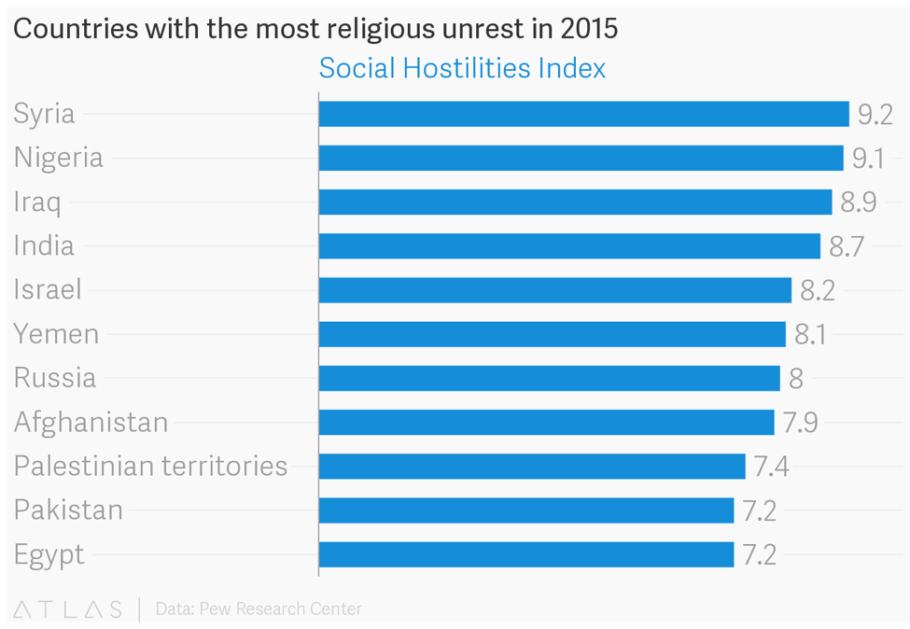
- Map of the social hostilities in each country in December 2015 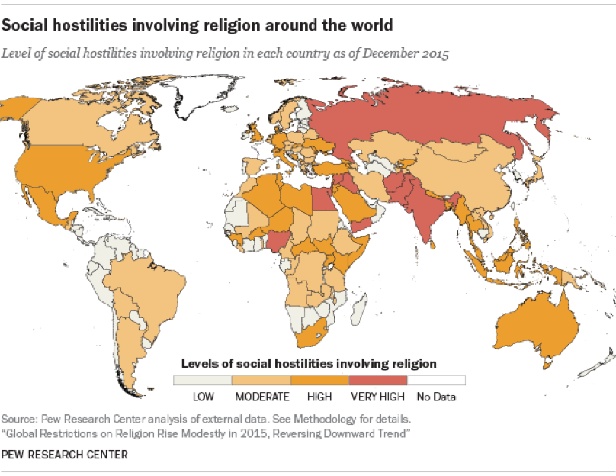

How Many Religions are there in the world? Available on: https://www.reference.com/world-view/many-religions-world-8f3af083e8592895?aq=how+many+religion+in+the+world&qo=cdpArticles#
The social and economic consequences of religious intolerance. Available on: https://www.ccwa.org/wp-content/uploads/2014/03/FINAL-ECOSOC-Background-Guide.pdf
Religious Intolerance. Available on: http://www.religioustolerance.org/relintol1.htm#dict
Religious Tolerance. Available on: http://www.religioustolerance.org/rel_tol.htm
Definition of Repercussions. Available on: http://www.dictionary.com/browse/repercussions?s=ts
Definition of Minority group. Available on: https://www.collinsdictionary.com/dictionary/english/minority-group
The activity of travelling to a place, mostly for fun Definition of Tourism. Available on: http://www.dictionary.com/browse/tourism?s=t
a person that moves from one region, place, or country to another Definition of Migrant. Available on: http://www.dictionary.com/browse/migrant?s=t
Definition of Prejudice. Available on: http://www.dictionary.com/browse/prejudice?s=t
Report on the special Rapporteur on minority issues Rita Izsák. Available on: https://www.ohchr.org/EN/HRBodies/HRC/RegularSessions/Session28/_layouts/15/WopiFrame.aspx?sourcedoc=/EN/HRBodies/HRC/RegularSessions/Session28/Documents/A_HRC_28_64_ENG.doc&action=default&DefaultItemOpen=1
Social hostility is the mistreatment and unfriendly behavior of social groups towards certain religious individuals or groups.
Religion. Available on: http://censusindia.gov.in/Census_And_You/religion.aspx
Religious violence in Myanmar, the consequences of Government inaction in tackling prejudice and discrimination – UN expert. Available on: https://reliefweb.int/report/myanmar/religious-violence-myanmar-consequences-government-inaction-tackling-prejudice-and
Institute for Religious Tolerance, Peace and Justice. Available on: https://www.instituteforreligioustolerance.org/
The act of spreading of the Christian religion
Religious intolerance and oppression: Russia. Available on: http://www.religioustolerance.org/rt_russi.htm
General Assembly resolution 1981. Available on http://www.un.org/documents/ga/res/36/a36r055.htm
General Assembly resolution 1993. Available on http://www.un.org/documents/ga/res/48/a48r128.htm
General Assembly resolution 1997. Available on http://www.un.org/documents/ga/res/51/ares51-93.htm
A prolonged public dispute or debate Definition of Controversy. Available on:http://www.dictionary.com/browse/controversy?s=ts
a practical advantage given to one over others. Definition of Preference, Available on: http://www.dictionary.com/browse/preference?s=t
Countries with the most religious unrest in 2015. Available on: https://www.theatlas.com/charts/HkAzWY06g
Social Hostilities involving religions around the world. Available on: http://www.pewforum.org/2017/04/11/government-restrictions-rise-in-nearly-all-regions-in-2015/pf-04-11-2017_-restrictions-03-01/
dependent on each other Definition of Interdependence. Available on: http://www.dictionary.com/browse/interdependence?s=t

